RSCG Examples

Andrei Ignat

Table of Contents

## About this book

### Content of the book

You will find in this book code examples about >10 Roslyn Source Code Generator (RSCG) that can be useful for you. That means, you will write more elegant and concise code - even if the generators code is not always nice to look.

### Are those examples ready for production?

I have done due diligence to test the RSCG that I have shown to you here. However, I cannot guarantee that will fit your code. That means that you can test it for your case and, because all are open source on Github.com, you can contribute to improve them ;-)

### How to read this book

For each chapter, you will find

1. Name of the RSCG and link to the NuGet package / GitHub repository
2. What the RSCG can do
3. What you need to include in .csproj file
4. What will be the initial code
5. How to use the Code generated by RSCG
6. Code Generated by RSCG
7. Link to the downloadable code to practice

### I have a suggestion for a new RSCG that is worth mentioning in this book. What can I do?

Please send me an email to [ignatandrei@yahoo.com](mailto:ignatandrei@yahoo.com)

### I want to make a RSCG that will be useful. How can I do?

In the introduction I have put the links to get you started with RSCG.

And, if you bought this book from Amazon, you are entitled to have 1 hour free of consultancy with me. I can help you make one.

### I want the book / sponsor you

Glad that you have asked. Please goto Amazon: <https://amzn.to/3f6gll3>

( and this will remain free: <https://ignatandrei.github.io/RSCG_Examples/>)

## About the author



My name is Andrei Ignat and I have 20+ years programming experience.

I have started from VB3 , passed via plain old ASP

I am C# Microsoft Most Valuable Professional, and also <https://forums.asp.net> moderator .

Before that I was a teacher.

I am available also on

LinkedIN : <http://ro.linkedin.com/in/ignatandrei>

Facebook : <http://www.facebook.com/ignat.andrei>

Twitter: <http://twitter.com/ignatandrei>

You can ask me any .NET related question . I will be glad to answer – if I know the answer. If not, I will learn.

## Introduction

### What is a Roslyn Source Code Generator?

A Roslyn Source Code Generator (RSCG) is a program that generates code in the compile time, based on the previous source code and/or another data. This new source code is added to the compilation and compile with the previous source code.

### How can I make a Roslyn Source Code Generator?

For creating the RSCG you will simply create a .NET Standard 2.0 project, add those 2 references

<PackageReference Include="Microsoft.CodeAnalysis.Analyzers" Version="3.3.1" PrivateAssets="all" />  
 <PackageReference Include="Microsoft.CodeAnalysis.CSharp" Version="3.8.0" />

and start implementing

public interface ISourceGenerator  
{  
 void Initialize(GeneratorInitializationContext context);  
 void Execute(GeneratorExecutionContext context);  
}

Start from examples at <https://github.com/dotnet/roslyn-sdk/tree/main/samples/CSharp/SourceGenerators> Also, you can read the source code for the RSCG presented in this book.

### Show me some code for RSCG

Start read

<https://github.com/dotnet/roslyn/blob/main/docs/features/source-generators.md>

and

<https://github.com/dotnet/roslyn/blob/main/docs/features/source-generators.cookbook.md> .

After that, you can play with the examples from <https://github.com/dotnet/roslyn-sdk/tree/main/samples/CSharp/SourceGenerators> or from <https://sourcegen.dev/> (see AutoNotify in the dropdown)

### How the RSCG can help me to write faster / better the code ?

Glad that you asked. You can see in action a RSCG for automatically generating code for automating testing (see DynamicMocking ) , parsing enum (see Enum ) , generating controllers actions from a interface ( SkinnyControllers ), currying functions and many more. In this book you will find more than 10 examples of some RSCG that can help you. Also, you can find the source code of the examples at <https://github.com/ignatandrei/RSCG_Examples>.

## RSCG number 1 : ThisAssembly

### What RSCG ThisAssembly can do

The ThisAssembly.Info allows you access to the Assembly Information as constants, instead of going to reflection each time. I found useful to see the assembly version right away in any project that I have.

### Example code

#### Here is the csproj with the references for RSCG ThisAssembly

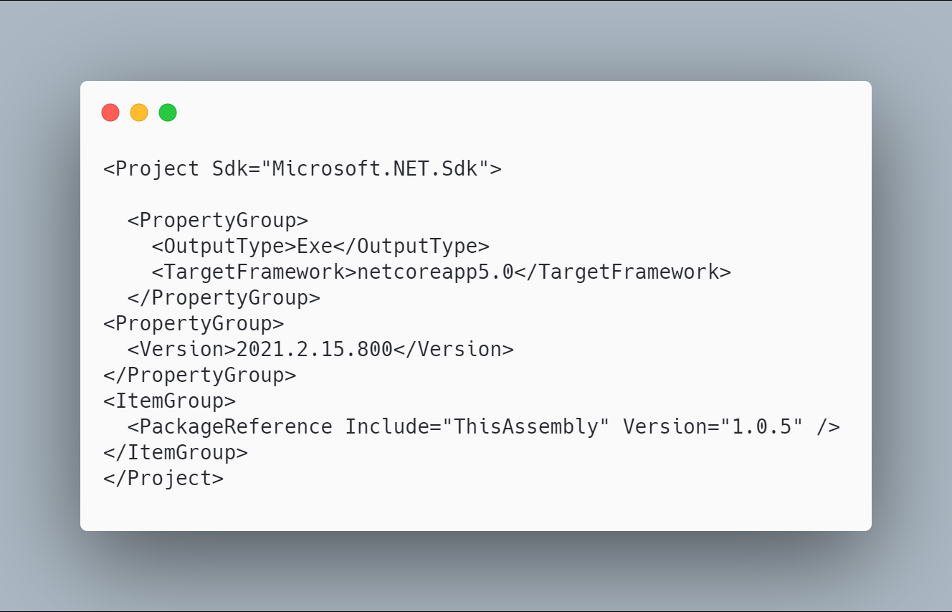 [code](http://ignatandrei.github.io/RSCG_Examples/images/ThisAssembly/The.csproj)

#### The initial code that you start with is

 [code](http://ignatandrei.github.io/RSCG_Examples/images/ThisAssembly/ExistingCode.cs)

#### The code below will use the RSCG ThisAssembly

 [code](http://ignatandrei.github.io/RSCG_Examples/images/ThisAssembly/Usage.cs)

#### The code that is generated by RSCG ThisAssembly

 [code](http://ignatandrei.github.io/RSCG_Examples/images/ThisAssembly/GeneratedCode.cs)

### More details about RSCG ThisAssembly

The author of **RSCG ThisAssembly** is *Daniel Cazzulino*

You cand find **RSCG ThisAssembly** at Nuget.org : <https://www.nuget.org/packages/ThisAssembly> and the sources at <https://github.com/devlooped/ThisAssembly>

For more usage features please read : <https://www.clarius.org/ThisAssembly/>

#### Link to Example Code:

[<https://github.com/ignatandrei/RSCG_Examples/tree/main/ApplicationVersion>](https://github.com/ignatandrei/RSCG_Examples/tree/main/ApplicationVersion)

## RSCG number 2 : Enum

### What RSCG Enum can do

This will generate code to fast parsing a int or a string to an enum

### Example code

#### Here is the csproj with the references for RSCG Enum

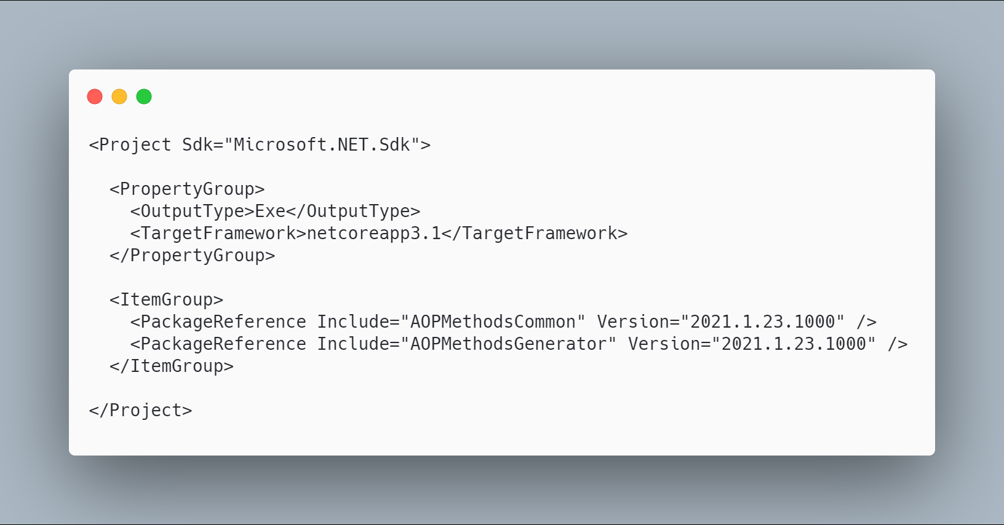 [code](http://ignatandrei.github.io/RSCG_Examples/images/Enum/The.csproj)

#### The initial code that you start with is

 [code](http://ignatandrei.github.io/RSCG_Examples/images/Enum/ExistingCode.cs)

#### The code below will use the RSCG Enum

 [code](http://ignatandrei.github.io/RSCG_Examples/images/Enum/Usage.cs)

#### The code that is generated by RSCG Enum

 [code](http://ignatandrei.github.io/RSCG_Examples/images/Enum/GeneratedCode.cs)

### More details about RSCG Enum

The author of **RSCG Enum** is *Andrei Ignat*

You cand find **RSCG Enum** at Nuget.org : <https://www.nuget.org/packages/AOPMethodsCommon/> <https://www.nuget.org/packages/AOPMethodsGenerator/> and the sources at <http://github.com/ignatandrei/aop_With_Roslyn/>

For more usage features please read : <http://msprogrammer.serviciipeweb.ro/category/roslyn/>

#### Link to Example Code:

[<https://github.com/ignatandrei/RSCG_Examples/tree/main/Enum>](https://github.com/ignatandrei/RSCG_Examples/tree/main/Enum)

## RSCG number 3 : JsonByExampleGenerator

### What RSCG JsonByExampleGenerator can do

This will generate C# classes from json files.

### Example code

#### Here is the csproj with the references for RSCG JsonByExampleGenerator

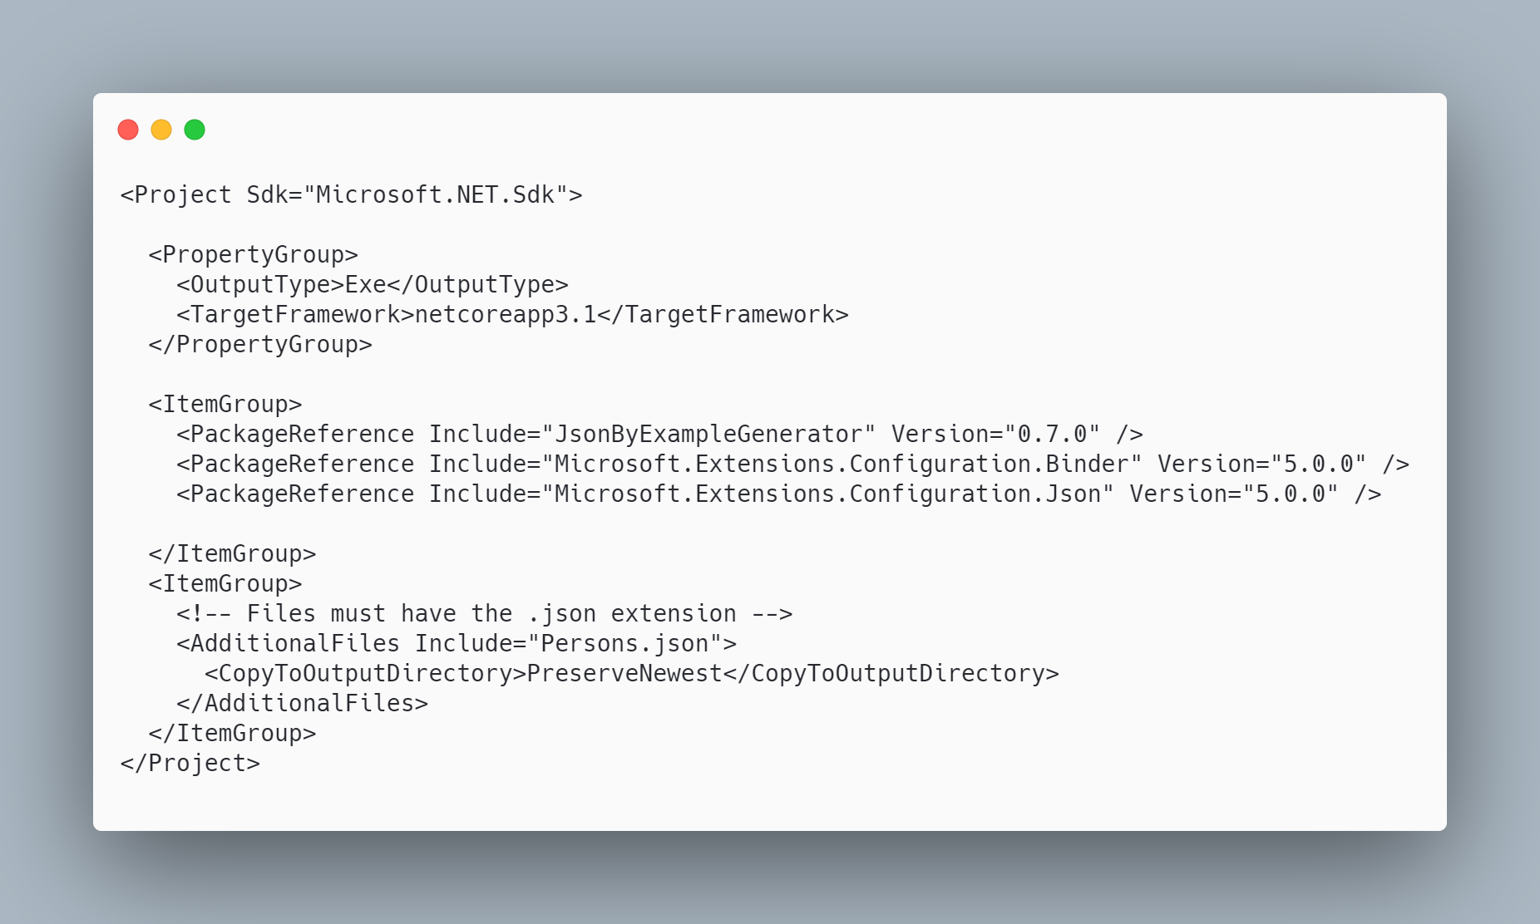 [code](http://ignatandrei.github.io/RSCG_Examples/images/JsonByExampleGenerator/The.csproj)

#### The initial code that you start with is

 [code](http://ignatandrei.github.io/RSCG_Examples/images/JsonByExampleGenerator/ExistingCode.cs)

#### The code below will use the RSCG JsonByExampleGenerator

 [code](http://ignatandrei.github.io/RSCG_Examples/images/JsonByExampleGenerator/Usage.cs)

#### The code that is generated by RSCG JsonByExampleGenerator

 [code](http://ignatandrei.github.io/RSCG_Examples/images/JsonByExampleGenerator/GeneratedCode.cs)

### More details about RSCG JsonByExampleGenerator

The author of **RSCG JsonByExampleGenerator** is *Robin Hermanussen*

You cand find **RSCG JsonByExampleGenerator** at Nuget.org : <https://www.nuget.org/packages/JsonByExampleGenerator/> and the sources at <https://github.com/hermanussen/JsonByExampleGenerator/>

For more usage features please read : <https://github.com/hermanussen/JsonByExampleGenerator/>

#### Link to Example Code:

[<https://github.com/ignatandrei/RSCG_Examples/tree/main/JsonToClass>](https://github.com/ignatandrei/RSCG_Examples/tree/main/JsonToClass)

### Author of JsonByExampleGenerator , Robin Hermanussen

#### Short info about you , Robin Hermanussen

I'm a Software Architect at Iquality (software company in the Netherlands). I'm passionate about software development in general, but with a particular interest in .NET.

#### Why did you start this JsonByExampleGenerator ?

I have written a bunch of C# analyzers in the past that served specific needs and now wanted to get some experience in writing source generators. It seemed like a good idea to me to generate classes based on example JSON, because it replaces a task that I often find a bit tedious; writing data contract classes and then tests to ensure they get properly (de)serialized with the JSON that I'm using.

#### How do yourself use your JsonByExampleGenerator ?

I'm not really using it in real world projects right now, as I'm not working on any projects that require it.

#### What other RSCG do you use ?

I've used ThisAssembly and a few others, for learning purposes.

#### Any other feedback ?

If anyone wants to use JsonByExampleGenerator and give me feedback from the real world, let me know! I'll be happy to help out with any issues or questions you may run into. Just add an issue to the project on GitHub to get in touch.

## RSCG number 4 : CopyConstructor + Deconstructor

### What RSCG CopyConstructor + Deconstructor can do

This will generate code for a POCO to generate copy constructor and deconstructor

### Example code

#### Here is the csproj with the references for RSCG CopyConstructor + Deconstructor

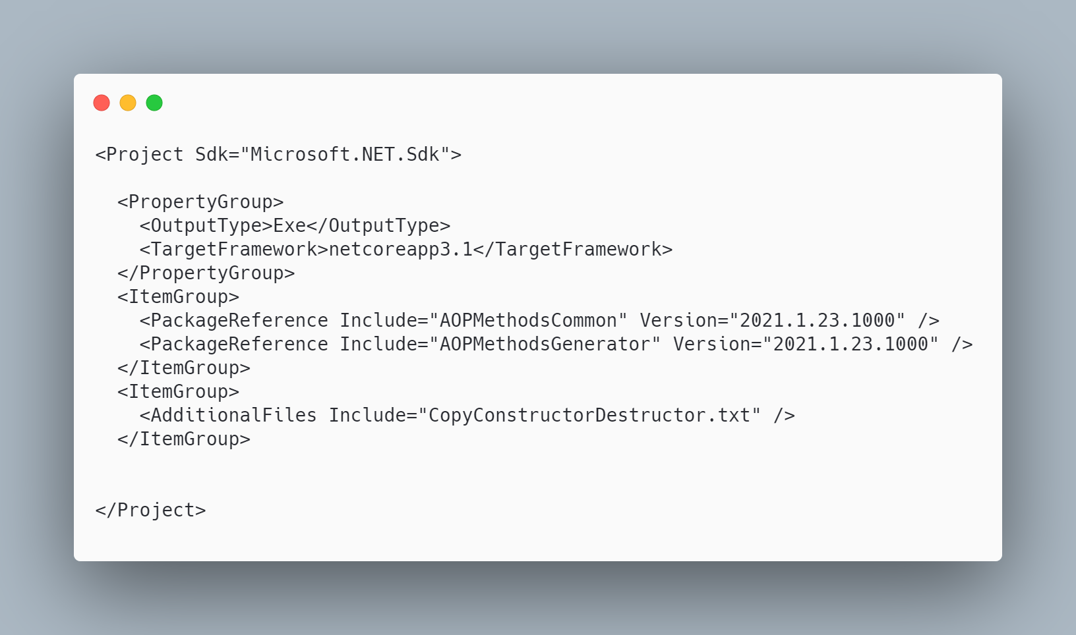 [code](http://ignatandrei.github.io/RSCG_Examples/images/CopyConstructor%20+%20Deconstructor/The.csproj)

#### The initial code that you start with is

 [code](http://ignatandrei.github.io/RSCG_Examples/images/CopyConstructor%20+%20Deconstructor/ExistingCode.cs)

#### The code below will use the RSCG CopyConstructor + Deconstructor

 [code](http://ignatandrei.github.io/RSCG_Examples/images/CopyConstructor%20+%20Deconstructor/Usage.cs)

#### The code that is generated by RSCG CopyConstructor + Deconstructor

 [code](http://ignatandrei.github.io/RSCG_Examples/images/CopyConstructor%20+%20Deconstructor/GeneratedCode.cs)

### More details about RSCG CopyConstructor + Deconstructor

The author of **RSCG CopyConstructor + Deconstructor** is *Andrei Ignat*

You cand find **RSCG CopyConstructor + Deconstructor** at Nuget.org : <https://www.nuget.org/packages/AOPMethodsCommon/> <https://www.nuget.org/packages/AOPMethodsGenerator/> and the sources at <http://github.com/ignatandrei/aop_With_Roslyn/>

For more usage features please read : <http://msprogrammer.serviciipeweb.ro/category/roslyn/>

#### Link to Example Code:

[<https://github.com/ignatandrei/RSCG_Examples/tree/main/CopyConstructor>](https://github.com/ignatandrei/RSCG_Examples/tree/main/CopyConstructor)

## RSCG number 5 : GeneratedMapper

### What RSCG GeneratedMapper can do

AutoMapping from a POCO to a DTO. Lots of customizations

### Example code

#### Here is the csproj with the references for RSCG GeneratedMapper

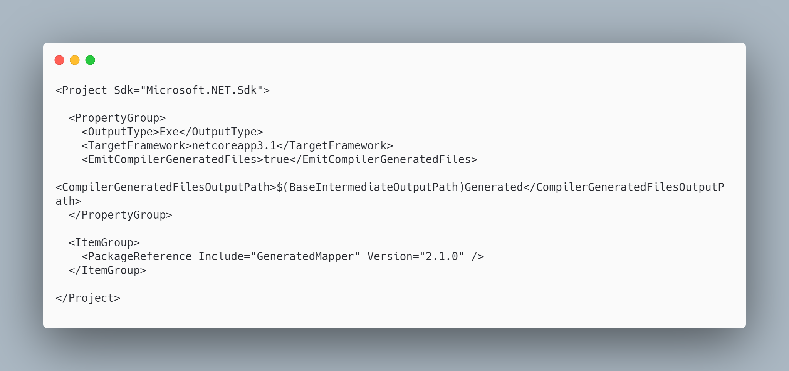 [code](http://ignatandrei.github.io/RSCG_Examples/images/GeneratedMapper/The.csproj)

#### The initial code that you start with is

 [code](http://ignatandrei.github.io/RSCG_Examples/images/GeneratedMapper/ExistingCode.cs)

#### The code below will use the RSCG GeneratedMapper

 [code](http://ignatandrei.github.io/RSCG_Examples/images/GeneratedMapper/Usage.cs)

#### The code that is generated by RSCG GeneratedMapper

 [code](http://ignatandrei.github.io/RSCG_Examples/images/GeneratedMapper/GeneratedCode.cs)

### More details about RSCG GeneratedMapper

The author of **RSCG GeneratedMapper** is *Thomas Bleijendaal*

You cand find **RSCG GeneratedMapper** at Nuget.org : <https://www.nuget.org/packages/GeneratedMapper/> and the sources at <https://github.com/ThomasBleijendaal/GeneratedMapper>

For more usage features please read : <https://github.com/ThomasBleijendaal/GeneratedMapper>

#### Link to Example Code:

[<https://github.com/ignatandrei/RSCG_Examples/tree/main/DTOMapper>](https://github.com/ignatandrei/RSCG_Examples/tree/main/DTOMapper)

### Author of GeneratedMapper , Thomas Bleijendaal

#### Short info about you , Thomas Bleijendaal

I'm Thomas Bleijendaal, I'm a .NET developer working for Triple in Alkmaar, The Netherlands.

#### Why did you start this GeneratedMapper ?

I've started GeneratedMapper to get more familiar with source generation. While the tooling is a bit rough now, I do believe that this feature can really bring a lot of value to .NET.

I've been burned before by a lot of hard-to-find bugs caused by badly behaving mappers and runtime surprises from badly handled null-references. I wanted to create a object-to-object mapper that would be very picky and raise compilation errors instead of runtime exceptions. Being able to see what the mapper will do by simply inspecting the code is very handy, and makes you trust your mapper even more.

#### How do yourself use your GeneratedMapper ?

I use the GeneratedMapper in a project where I map models coming from Contentful to DTOs that are used in views. I've also tried to use it in another project, but because that targeted an older runtime I could not make that work. But, since I could copy all the generated mappers and maintain those manually, switching away from it wasn't that bad. I think that is also very valuable of code generation, you still have a copy of what a generator made for you.

#### What other RSCG do you use ?

I haven't really used any other RSCGs yet, other than a metadata generator that Microsoft made for the out-of-process .NET-based Azure Functions (<https://github.com/Azure/azure-functions-dotnet-worker/>). That stuff is all very preview still, so it could be removed from the product, but it's cool to see Microsoft starting to use it too.

#### Any other feedback ?

Cool book!

## RSCG number 6 : Skinny Controllers

### What RSCG Skinny Controllers can do

This will generate code for WebAPI for each method of a field in the controller

### Example code

#### Here is the csproj with the references for RSCG Skinny Controllers

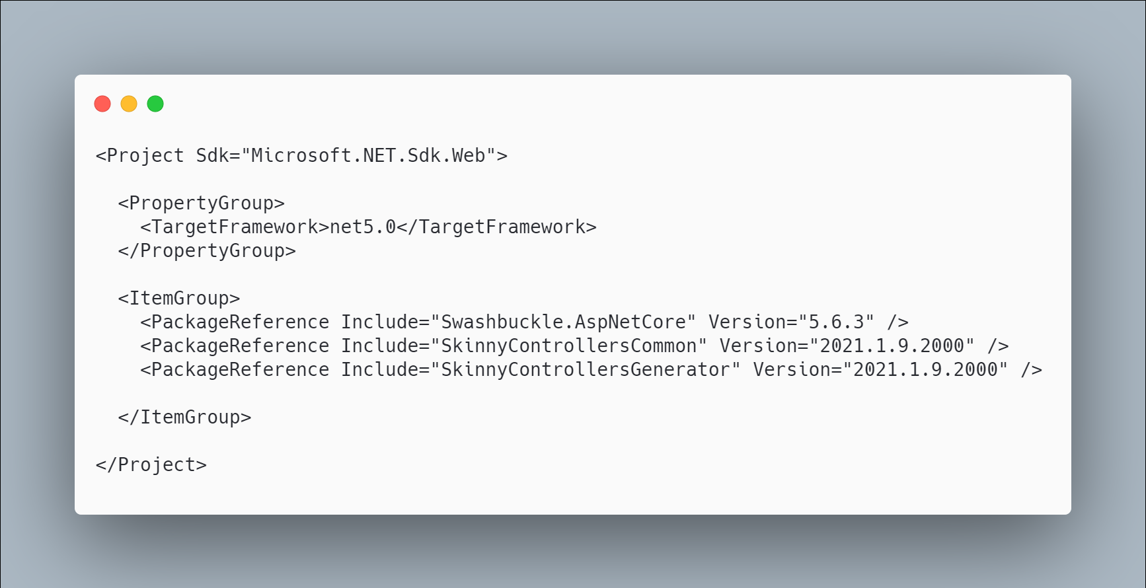 [code](http://ignatandrei.github.io/RSCG_Examples/images/Skinny%20Controllers/The.csproj)

#### The initial code that you start with is

 [code](http://ignatandrei.github.io/RSCG_Examples/images/Skinny%20Controllers/ExistingCode.cs)

#### The code below will use the RSCG Skinny Controllers

 [code](http://ignatandrei.github.io/RSCG_Examples/images/Skinny%20Controllers/Usage.cs)

#### The code that is generated by RSCG Skinny Controllers

 [code](http://ignatandrei.github.io/RSCG_Examples/images/Skinny%20Controllers/GeneratedCode.cs)

### More details about RSCG Skinny Controllers

The author of **RSCG Skinny Controllers** is *Andrei Ignat*

You cand find **RSCG Skinny Controllers** at Nuget.org : <https://www.nuget.org/packages/SkinnyControllersCommon/> <https://www.nuget.org/packages/SkinnyControllersGenerator/> and the sources at <http://github.com/ignatandrei/aop_With_Roslyn/>

For more usage features please read : <http://msprogrammer.serviciipeweb.ro/category/roslyn/>

#### Link to Example Code:

[<https://github.com/ignatandrei/RSCG_Examples/tree/main/SkinnyControllers>](https://github.com/ignatandrei/RSCG_Examples/tree/main/SkinnyControllers)

## RSCG number 7 : data-builder-generator

### What RSCG data-builder-generator can do

Implements the Builder Design pattern for any class. Useful , at least, for test projects

### Example code

#### Here is the csproj with the references for RSCG data-builder-generator

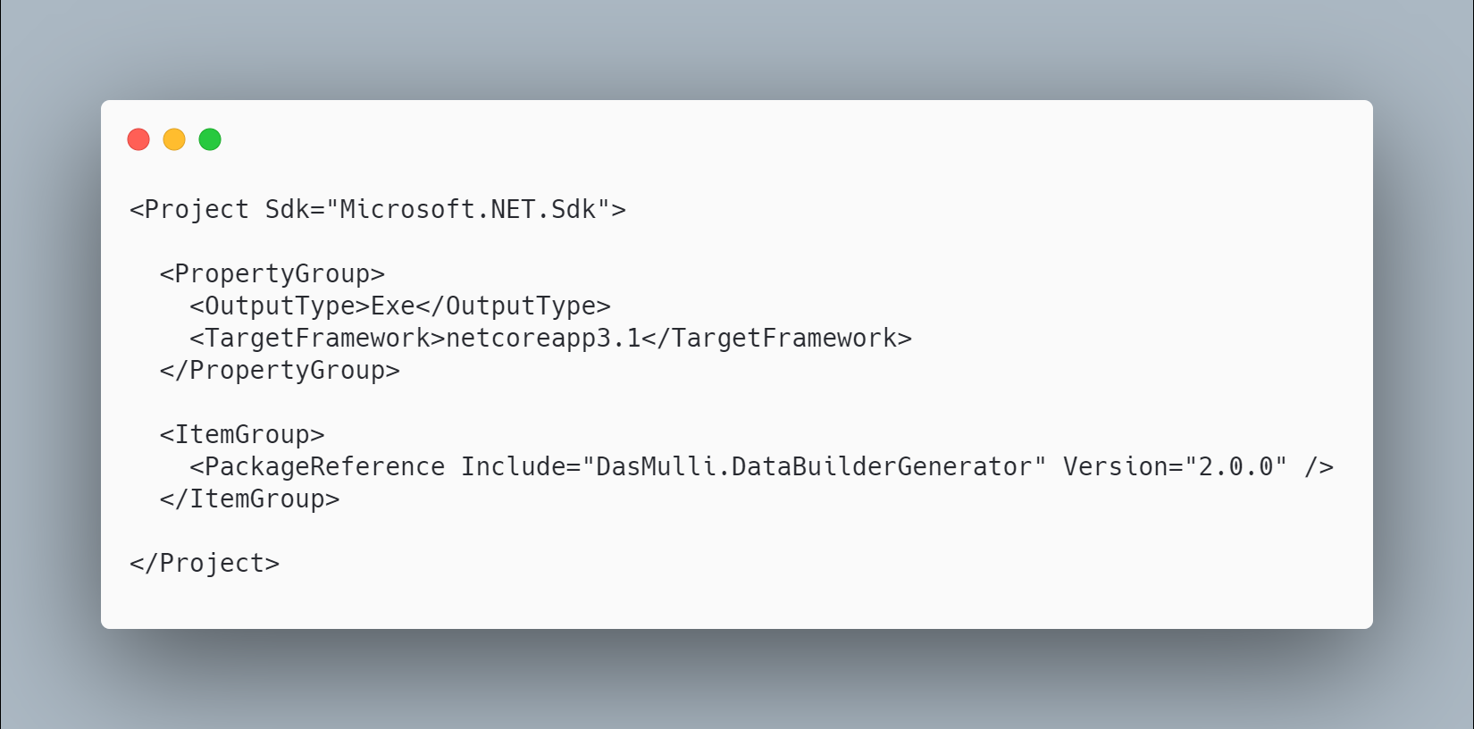 [code](http://ignatandrei.github.io/RSCG_Examples/images/data-builder-generator/The.csproj)

#### The initial code that you start with is

 [code](http://ignatandrei.github.io/RSCG_Examples/images/data-builder-generator/ExistingCode.cs)

#### The code below will use the RSCG data-builder-generator

 [code](http://ignatandrei.github.io/RSCG_Examples/images/data-builder-generator/Usage.cs)

#### The code that is generated by RSCG data-builder-generator

 [code](http://ignatandrei.github.io/RSCG_Examples/images/data-builder-generator/GeneratedCode.cs)

### More details about RSCG data-builder-generator

The author of **RSCG data-builder-generator** is *Martin Andreas Ulrich*

You cand find **RSCG data-builder-generator** at Nuget.org : <https://www.nuget.org/packages/DasMulli.DataBuilderGenerator/> and the sources at <https://github.com/dasMulli/data-builder-generator>

For more usage features please read : <https://github.com/dasMulli/data-builder-generator>

#### Link to Example Code:

[<https://github.com/ignatandrei/RSCG_Examples/tree/main/DP_Builder>](https://github.com/ignatandrei/RSCG_Examples/tree/main/DP_Builder)

### Author of data-builder-generator , Martin Andreas Ulrich

#### Short info about you , Martin Andreas Ulrich

I am a software engineer working on diverse tech stacks but focusing mostly on .NET in C#, Web Technologies and iOS/Swift.

I am a technology enthusiast who always works on improving development and DevOps processes at our company to make life easier for developers and help deliver high. I was awarded Microsoft MVP for community and open-source work around .NET Core.

#### Why did you start this data-builder-generator ?

#### How do yourself use your data-builder-generator ?

In "enterprise" contexts (I hate that term) one usually has to deal with business logic working on data objects. Writing tests is really important in these contexts but creating lots of test data for various scenarios can be quite cumbersome. You usually have some set of defaults (e.g. a base order with a dummy customer and items, an insurance application from a dummy customer etc.) and then deviate from it a little for each scenario. This is where C# 9 records would come in handy, but they were at the time not released and adopting them could be challenging (e.g. proper EF support while we're still on EF Core 3.1 anyway) so we opted for a test data builder approach where the builder classes would be generated. I did something similar a few years back at a previous company based on <https://github.com/AArnott/CodeGeneration.Roslyn> (which is now archived in favor of rolsyn source generators) and decided that for a current project I'll have a go and try to create something similar based on roslyn. While there are still a few bugs in the generator (get-only properties for example), this works quite well just annotating all EF model POCOs and then creating a few default builders that can be used from tests (Think TestData.DefaultOrder.WithoutCustomerAddress().Build() - extension methods are useful here as well to reuse builder functions that have a business meaning (.WithChecksumMismatchingIBAN())). I hope that many of these concerns can be solved with records in the future, so each .WithXYZ() can be done as a proper with-expression. But until then, autogenerating builder patterns is a good approach. I wanted to hold off refactoring / fixing bugs for advanced use cases until a few first-party generators exist and we know what performance pitfalls to look out for. Since we were using them when generators were in preview, we also had to deal with breaking changes in the API which was a bit of pain.

#### What other RSCG do you use ?

Currently this is the only one. I hope that OpenAPI processing / generation will be a source generator soon - this is currently patched in via NSwag/MSBuild for some projects.

#### Any other feedback ?

As mentioned I hope that some patterns of how to implement fast source generators emerge. This one likely isn't the best but I wanted to hold off a few months before refactoring. I don't plan on making a huge deal out of it, I just thought it's good to put useful tools we're building on GitHub for discussion and maybe it helps someone else as well.

## RSCG number 8 : Metadata from object

### What RSCG Metadata from object can do

This will generate code to retrieve the values of properties directly, not by reflection

### Example code

#### Here is the csproj with the references for RSCG Metadata from object

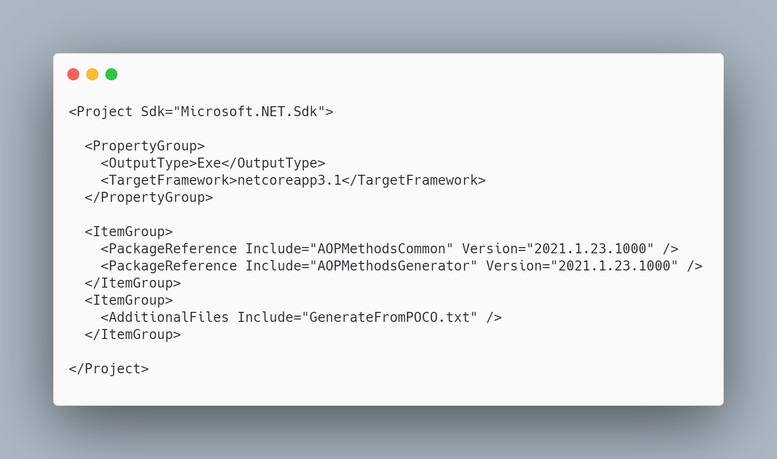 [code](http://ignatandrei.github.io/RSCG_Examples/images/Metadata%20from%20object/The.csproj)

#### The initial code that you start with is

 [code](http://ignatandrei.github.io/RSCG_Examples/images/Metadata%20from%20object/ExistingCode.cs)

#### The code below will use the RSCG Metadata from object

 [code](http://ignatandrei.github.io/RSCG_Examples/images/Metadata%20from%20object/Usage.cs)

#### The code that is generated by RSCG Metadata from object

 [code](http://ignatandrei.github.io/RSCG_Examples/images/Metadata%20from%20object/GeneratedCode.cs)

### More details about RSCG Metadata from object

The author of **RSCG Metadata from object** is *Andrei Ignat*

You cand find **RSCG Metadata from object** at Nuget.org : <https://www.nuget.org/packages/AOPMethodsCommon/> <https://www.nuget.org/packages/AOPMethodsGenerator/> and the sources at <http://github.com/ignatandrei/aop_With_Roslyn/>

For more usage features please read : <http://msprogrammer.serviciipeweb.ro/category/roslyn/>

#### Link to Example Code:

[<https://github.com/ignatandrei/RSCG_Examples/tree/main/MetadataFromObject>](https://github.com/ignatandrei/RSCG_Examples/tree/main/MetadataFromObject)

## RSCG number 9 : MockSourceGenerator

### What RSCG MockSourceGenerator can do

This will generate Mock classes directly for any interface - with your implementation.

### Example code

#### Here is the csproj with the references for RSCG MockSourceGenerator

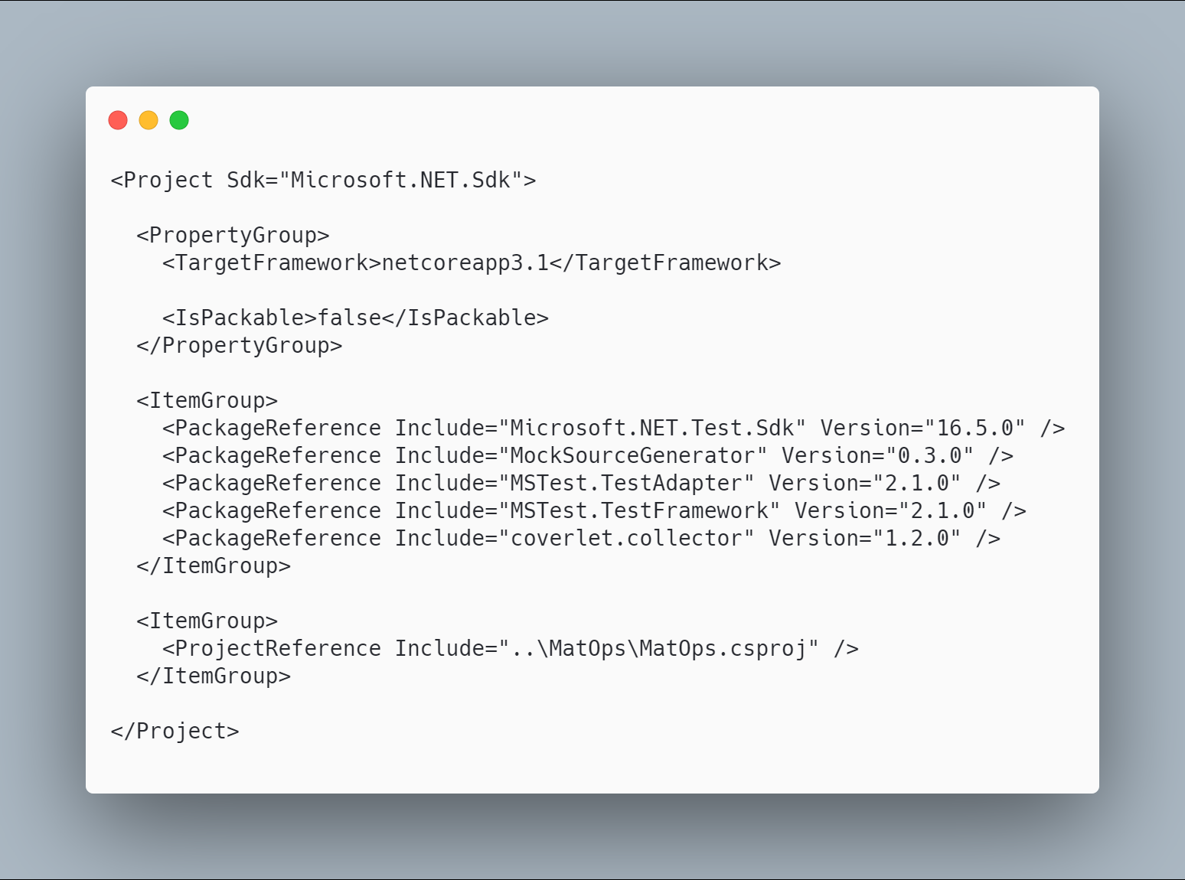 [code](http://ignatandrei.github.io/RSCG_Examples/images/MockSourceGenerator/The.csproj)

#### The initial code that you start with is

 [code](http://ignatandrei.github.io/RSCG_Examples/images/MockSourceGenerator/ExistingCode.cs)

#### The code below will use the RSCG MockSourceGenerator

 [code](http://ignatandrei.github.io/RSCG_Examples/images/MockSourceGenerator/Usage.cs)

#### The code that is generated by RSCG MockSourceGenerator

 [code](http://ignatandrei.github.io/RSCG_Examples/images/MockSourceGenerator/GeneratedCode.cs)

### More details about RSCG MockSourceGenerator

The author of **RSCG MockSourceGenerator** is *Robin Hermanussen*

You cand find **RSCG MockSourceGenerator** at Nuget.org : <https://www.nuget.org/packages/MockSourceGenerator/> and the sources at <https://github.com/hermanussen/MockSourceGenerator/>

For more usage features please read : <https://github.com/hermanussen/MockSourceGenerator/>

#### Link to Example Code:

[<https://github.com/ignatandrei/RSCG_Examples/tree/main/DynamicMocking>](https://github.com/ignatandrei/RSCG_Examples/tree/main/DynamicMocking)

### Author of MockSourceGenerator , Robin Hermanussen

#### Short info about you , Robin Hermanussen

I'm a Software Architect at Iquality (software company in the Netherlands). I'm passionate about software development in general, but with a particular interest in .NET.

#### Why did you start this MockSourceGenerator ?

I have written a bunch of C# analyzers in the past that served specific needs and now wanted to get some experience in writing source generators. The thing about libraries like Moq or NSubstitute that I don't really like is how it takes so much code to set them up and then I don't find them very readable. MockSourceGenerator takes an approach that allows people to mock something in a single statement (with an object initializer) and I think it is more readable this way.

#### How do yourself use your MockSourceGenerator ?

I'm not really using it in real world projects right now, as I'm not working on any projects that require it.

#### What other RSCG do you use ?

I've used ThisAssembly and a few others, for learning purposes.

#### Any other feedback ?

If anyone wants to use MockSourceGenerator and give me feedback from the real world, let me know! I'll be happy to help out with any issues or questions you may run into. Just add an issue to the project on GitHub to get in touch.

## RSCG number 10 : Method decorator

### What RSCG Method decorator can do

This will generate code to decorate methods with anything you want ( stopwatch, logging , authorization...)

### Example code

#### Here is the csproj with the references for RSCG Method decorator

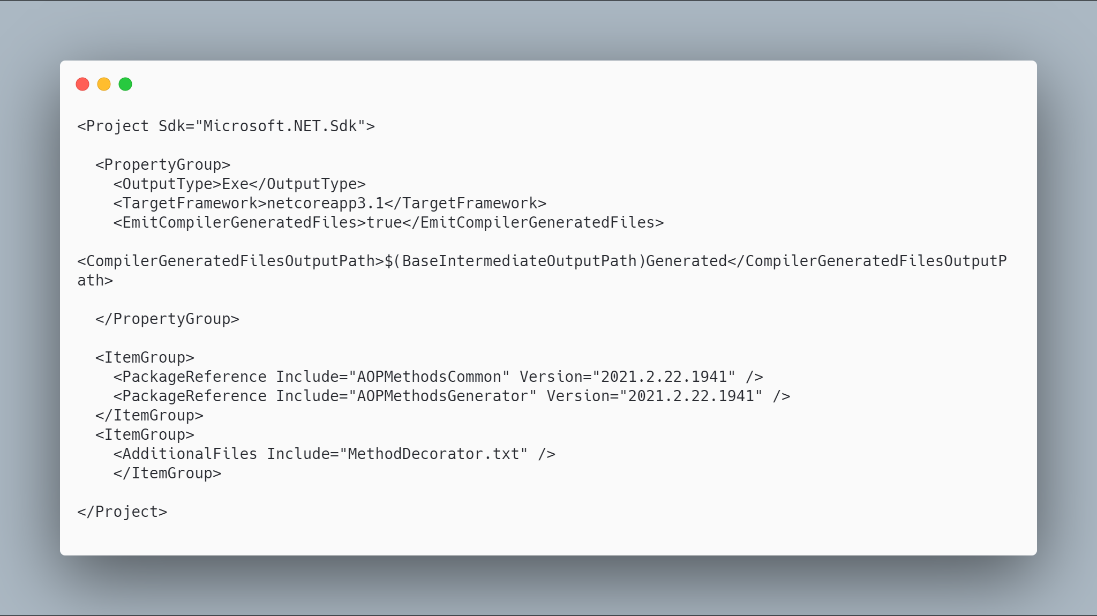 [code](http://ignatandrei.github.io/RSCG_Examples/images/Method%20decorator/The.csproj)

#### The initial code that you start with is

 [code](http://ignatandrei.github.io/RSCG_Examples/images/Method%20decorator/ExistingCode.cs)

#### The code below will use the RSCG Method decorator

 [code](http://ignatandrei.github.io/RSCG_Examples/images/Method%20decorator/Usage.cs)

#### The code that is generated by RSCG Method decorator

 [code](http://ignatandrei.github.io/RSCG_Examples/images/Method%20decorator/GeneratedCode.cs)

### More details about RSCG Method decorator

The author of **RSCG Method decorator** is *Andrei Ignat*

You cand find **RSCG Method decorator** at Nuget.org : <https://www.nuget.org/packages/AOPMethodsCommon/> <https://www.nuget.org/packages/AOPMethodsGenerator/> and the sources at <http://github.com/ignatandrei/aop_With_Roslyn/>

For more usage features please read : <http://msprogrammer.serviciipeweb.ro/category/roslyn/>

#### Link to Example Code:

[<https://github.com/ignatandrei/RSCG_Examples/tree/main/MethodDecorator>](https://github.com/ignatandrei/RSCG_Examples/tree/main/MethodDecorator)

## RSCG number 11 : PartiallyApplied

### What RSCG PartiallyApplied can do

This will generate curry for your functions

### Example code

#### Here is the csproj with the references for RSCG PartiallyApplied

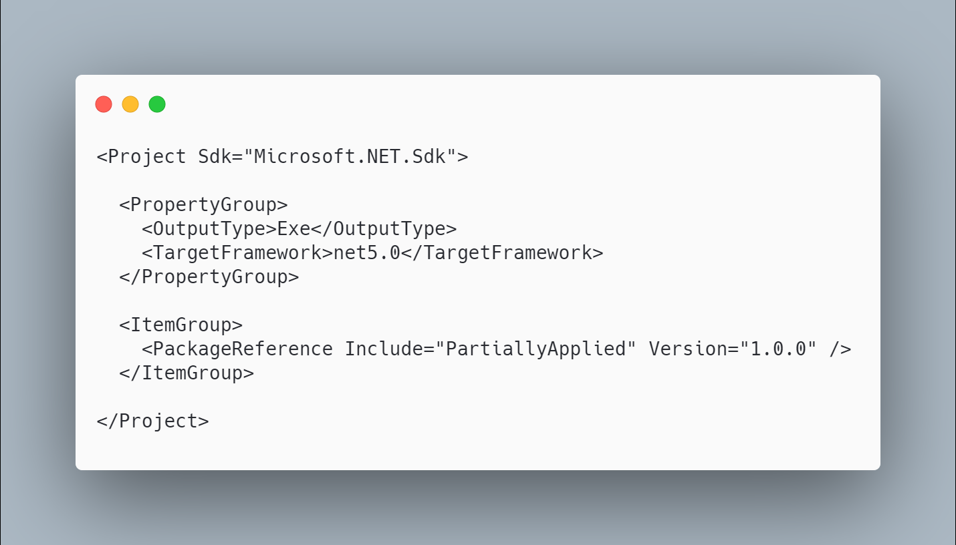 [code](http://ignatandrei.github.io/RSCG_Examples/images/PartiallyApplied/The.csproj)

#### The initial code that you start with is

 [code](http://ignatandrei.github.io/RSCG_Examples/images/PartiallyApplied/ExistingCode.cs)

#### The code below will use the RSCG PartiallyApplied

 [code](http://ignatandrei.github.io/RSCG_Examples/images/PartiallyApplied/Usage.cs)

#### The code that is generated by RSCG PartiallyApplied

 [code](http://ignatandrei.github.io/RSCG_Examples/images/PartiallyApplied/GeneratedCode.cs)

### More details about RSCG PartiallyApplied

The author of **RSCG PartiallyApplied** is *Jason Bock*

You cand find **RSCG PartiallyApplied** at Nuget.org : <https://www.nuget.org/packages/PartiallyApplied/> and the sources at <https://github.com/JasonBock/PartiallyApplied>

For more usage features please read : <https://github.com/JasonBock/PartiallyApplied>

#### Link to Example Code:

[<https://github.com/ignatandrei/RSCG_Examples/tree/main/PartiallyFunction>](https://github.com/ignatandrei/RSCG_Examples/tree/main/PartiallyFunction)

## RSCG number 12 : IFormattable

### What RSCG IFormattable can do

This will generate code to add IFormattable to any class, based on the properties of the class

### Example code

#### Here is the csproj with the references for RSCG IFormattable

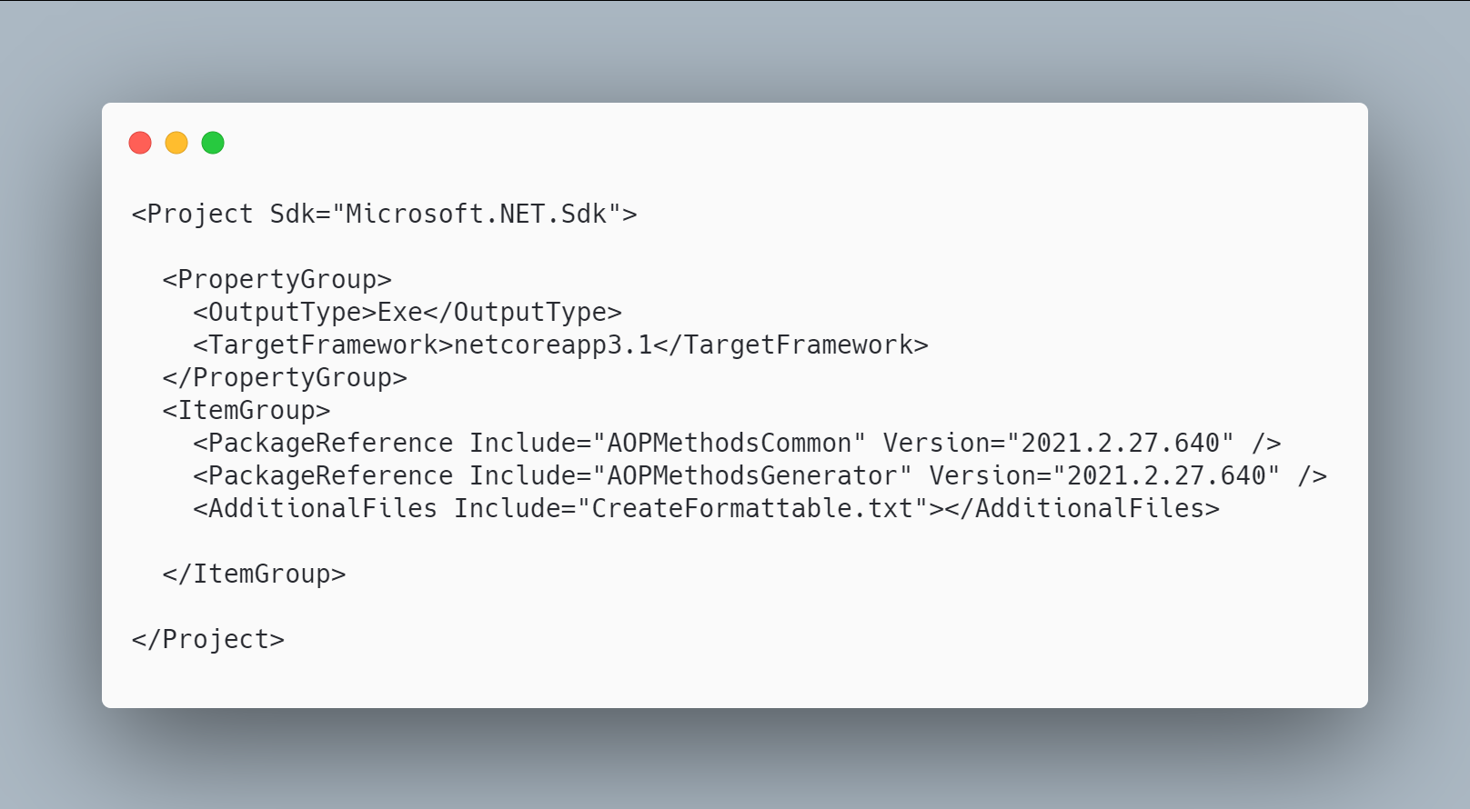 [code](http://ignatandrei.github.io/RSCG_Examples/images/IFormattable/The.csproj)

#### The initial code that you start with is

 [code](http://ignatandrei.github.io/RSCG_Examples/images/IFormattable/ExistingCode.cs)

#### The code below will use the RSCG IFormattable

 [code](http://ignatandrei.github.io/RSCG_Examples/images/IFormattable/Usage.cs)

#### The code that is generated by RSCG IFormattable

 [code](http://ignatandrei.github.io/RSCG_Examples/images/IFormattable/GeneratedCode.cs)

### More details about RSCG IFormattable

The author of **RSCG IFormattable** is *Andrei Ignat*

You cand find **RSCG IFormattable** at Nuget.org : <https://www.nuget.org/packages/AOPMethodsCommon/> <https://www.nuget.org/packages/AOPMethodsGenerator/> and the sources at <http://github.com/ignatandrei/aop_With_Roslyn/>

For more usage features please read : <http://msprogrammer.serviciipeweb.ro/category/roslyn/>

#### Link to Example Code:

[<https://github.com/ignatandrei/RSCG_Examples/tree/main/IFormattable>](https://github.com/ignatandrei/RSCG_Examples/tree/main/IFormattable)

## RSCG number 13 : AutoInterface

### What RSCG AutoInterface can do

Implement the Design Pattern Decorator. Based on template - you can modify the source code generated

### Example code

#### Here is the csproj with the references for RSCG AutoInterface

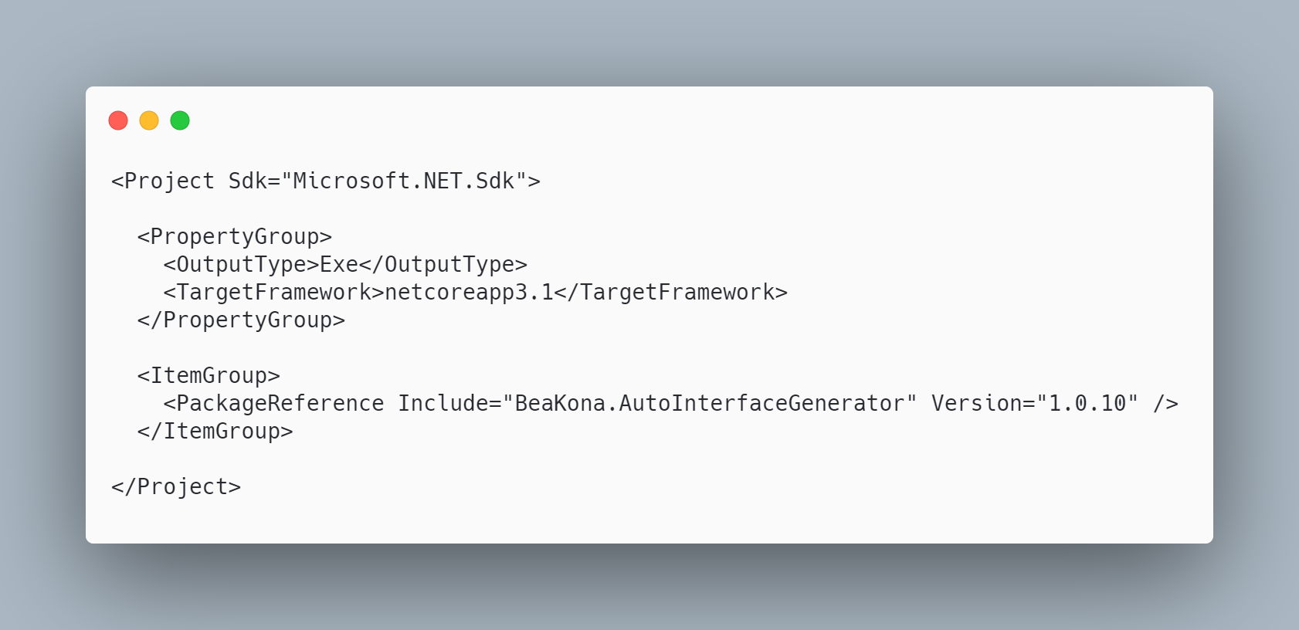 [code](http://ignatandrei.github.io/RSCG_Examples/images/AutoInterface/The.csproj)

#### The initial code that you start with is

 [code](http://ignatandrei.github.io/RSCG_Examples/images/AutoInterface/ExistingCode.cs)

#### The code below will use the RSCG AutoInterface

 [code](http://ignatandrei.github.io/RSCG_Examples/images/AutoInterface/Usage.cs)

#### The code that is generated by RSCG AutoInterface

 [code](http://ignatandrei.github.io/RSCG_Examples/images/AutoInterface/GeneratedCode.cs)

### More details about RSCG AutoInterface

The author of **RSCG AutoInterface** is *beakona*

You cand find **RSCG AutoInterface** at Nuget.org : <https://www.nuget.org/packages/BeaKona.AutoInterfaceGenerator> and the sources at <https://github.com/beakona/AutoInterface>

For more usage features please read : <https://github.com/beakona/AutoInterface>

#### Link to Example Code:

[<https://github.com/ignatandrei/RSCG_Examples/tree/main/DP_Decorator>](https://github.com/ignatandrei/RSCG_Examples/tree/main/DP_Decorator)

### Author of AutoInterface , beakona

#### Short info about you , beakona

I am a dad and software developer with more than 15 years of working experience in various industries and technologies. I am working mostly on embedded and desktop solutions mainly in C and C#.

#### Why did you start this AutoInterface ?

After the Source Generator public announcement, I decided to give them a try. I realized that Source Generators would allow us to explore composition-over-inheritance in its new form (from C# perspective). Technically, this approach uses interface invocation (which impacts performance) but one can view it as one form of composition. I consider myself a language designer and I wanted to explore the mechanics of this approach (regardless of poor performance) on existing and reputable language that I use daily.

#### How do yourself use your AutoInterface ?

I use it experimentally as a tool that allows a class to be composed-of-members and yet acts as inherited-as. Young and experimental languages have similar concepts as an alternative to inheritance. Those who find this interesting can explore the approach chosen by Jonathan Blow in its language Jai

#### What other RSCG do you use ?

There is only one Source Generator that I use in production; AutoCoder and it is not public because I didn't find time to make it configurable and polished. It automatically implements ICoding interface for the target class (Bridge pattern). I have been using this approach for years because the existing infrastructure does not work for me. The main concept is inspired by Foundation framework class NSCoder but is implemented in the C# way. Abstraction-side has two directions IEncoding/IDecoding and there are two implementers: IEncoder and IDecoder. AutoCoder acts on behalf of the abstraction side by offering targeted fields/properties to IEncoder/IDecoder. The author of IEncoder/IDecoder can decide what, how, when, and in which context to encode/decode. In other words, AutoCoder automates boring stuff and does not make typos.

#### Any other feedback ?

If you have special, funny, or helpful paragraphs that acts like mentor or life coach concept I think there is worth mentioning TED talk: Why you will fail to have a great career by Larry Smith or book: "Hold on to Your Kids: Why Parents Need to Matter More Than Peers", 2019, by Dr. Gabor Maté and Gordon Neufeld.

## RSCG number 14 : Property Expression Generator

### What RSCG Property Expression Generator can do

This will generate code to add function to be used with Entity Framework to search for any property of a class

### Example code

#### Here is the csproj with the references for RSCG Property Expression Generator

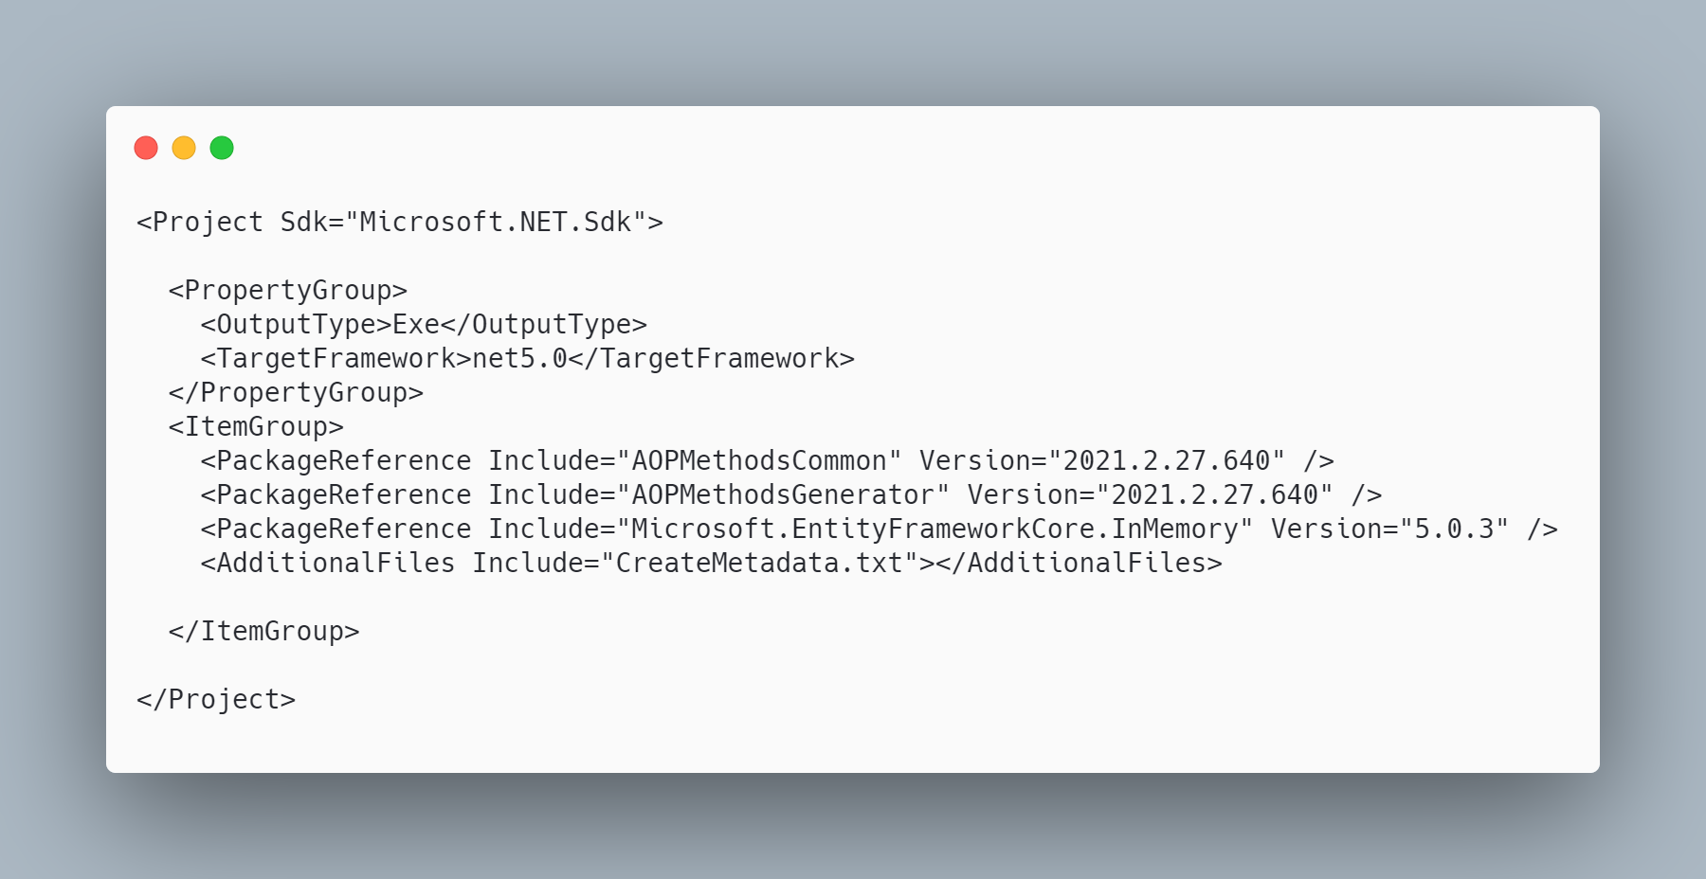 [code](http://ignatandrei.github.io/RSCG_Examples/images/Property%20Expression%20Generator/The.csproj)

#### The initial code that you start with is

 [code](http://ignatandrei.github.io/RSCG_Examples/images/Property%20Expression%20Generator/ExistingCode.cs)

#### The code below will use the RSCG Property Expression Generator

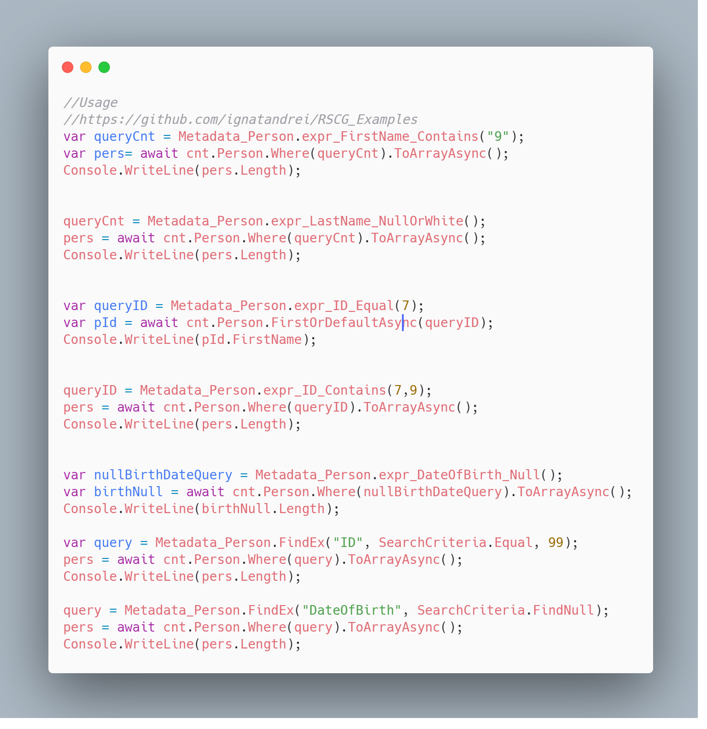 [code](http://ignatandrei.github.io/RSCG_Examples/images/Property%20Expression%20Generator/Usage.cs)

#### The code that is generated by RSCG Property Expression Generator

 [code](http://ignatandrei.github.io/RSCG_Examples/images/Property%20Expression%20Generator/GeneratedCode.cs)

### More details about RSCG Property Expression Generator

The author of **RSCG Property Expression Generator** is *Andrei Ignat*

You cand find **RSCG Property Expression Generator** at Nuget.org : <https://www.nuget.org/packages/AOPMethodsCommon/> <https://www.nuget.org/packages/AOPMethodsGenerator/> and the sources at <http://github.com/ignatandrei/aop_With_Roslyn/>

For more usage features please read : <http://msprogrammer.serviciipeweb.ro/category/roslyn/>

#### Link to Example Code:

[<https://github.com/ignatandrei/RSCG_Examples/tree/main/PropertyExpressionGenerator>](https://github.com/ignatandrei/RSCG_Examples/tree/main/PropertyExpressionGenerator)

## RSCG number 15 : Transplator

### What RSCG Transplator can do

The Transplator is a small fast rendering engine to allow you to make rendering from any class instance.

### Example code

#### Here is the csproj with the references for RSCG Transplator

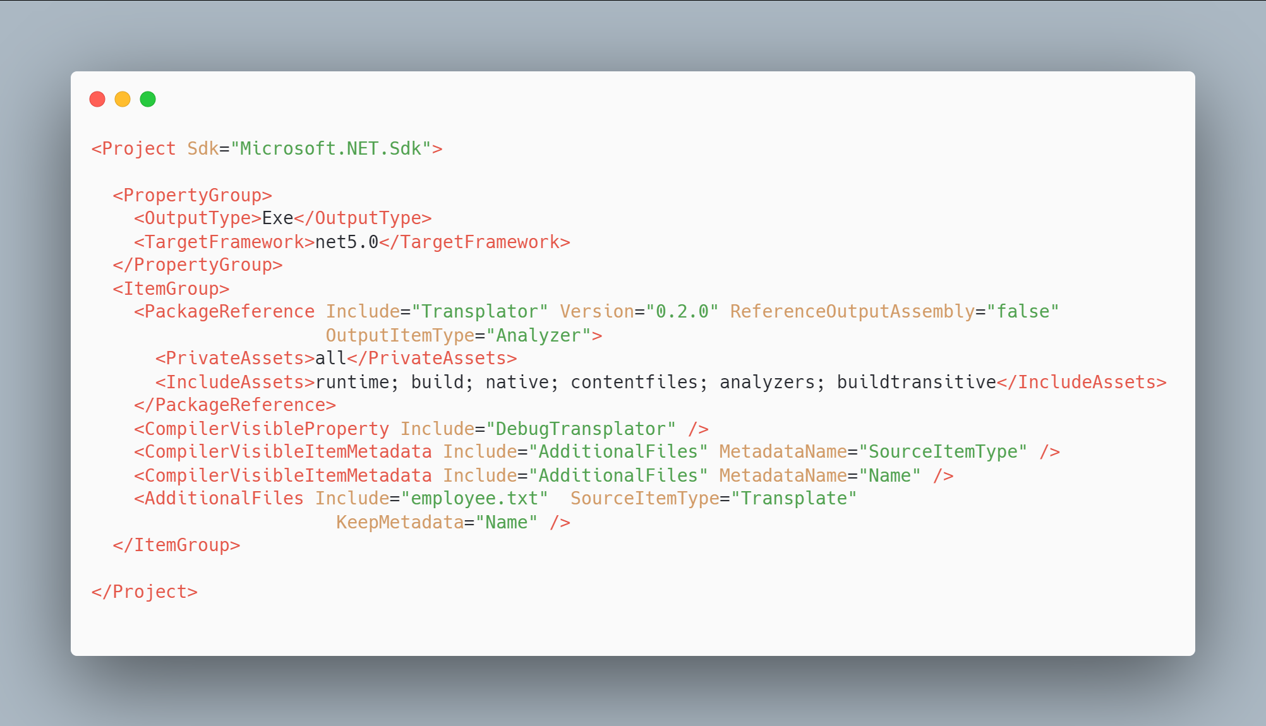 [code](http://ignatandrei.github.io/RSCG_Examples/images/Transplator/The.csproj)

#### The initial code that you start with is

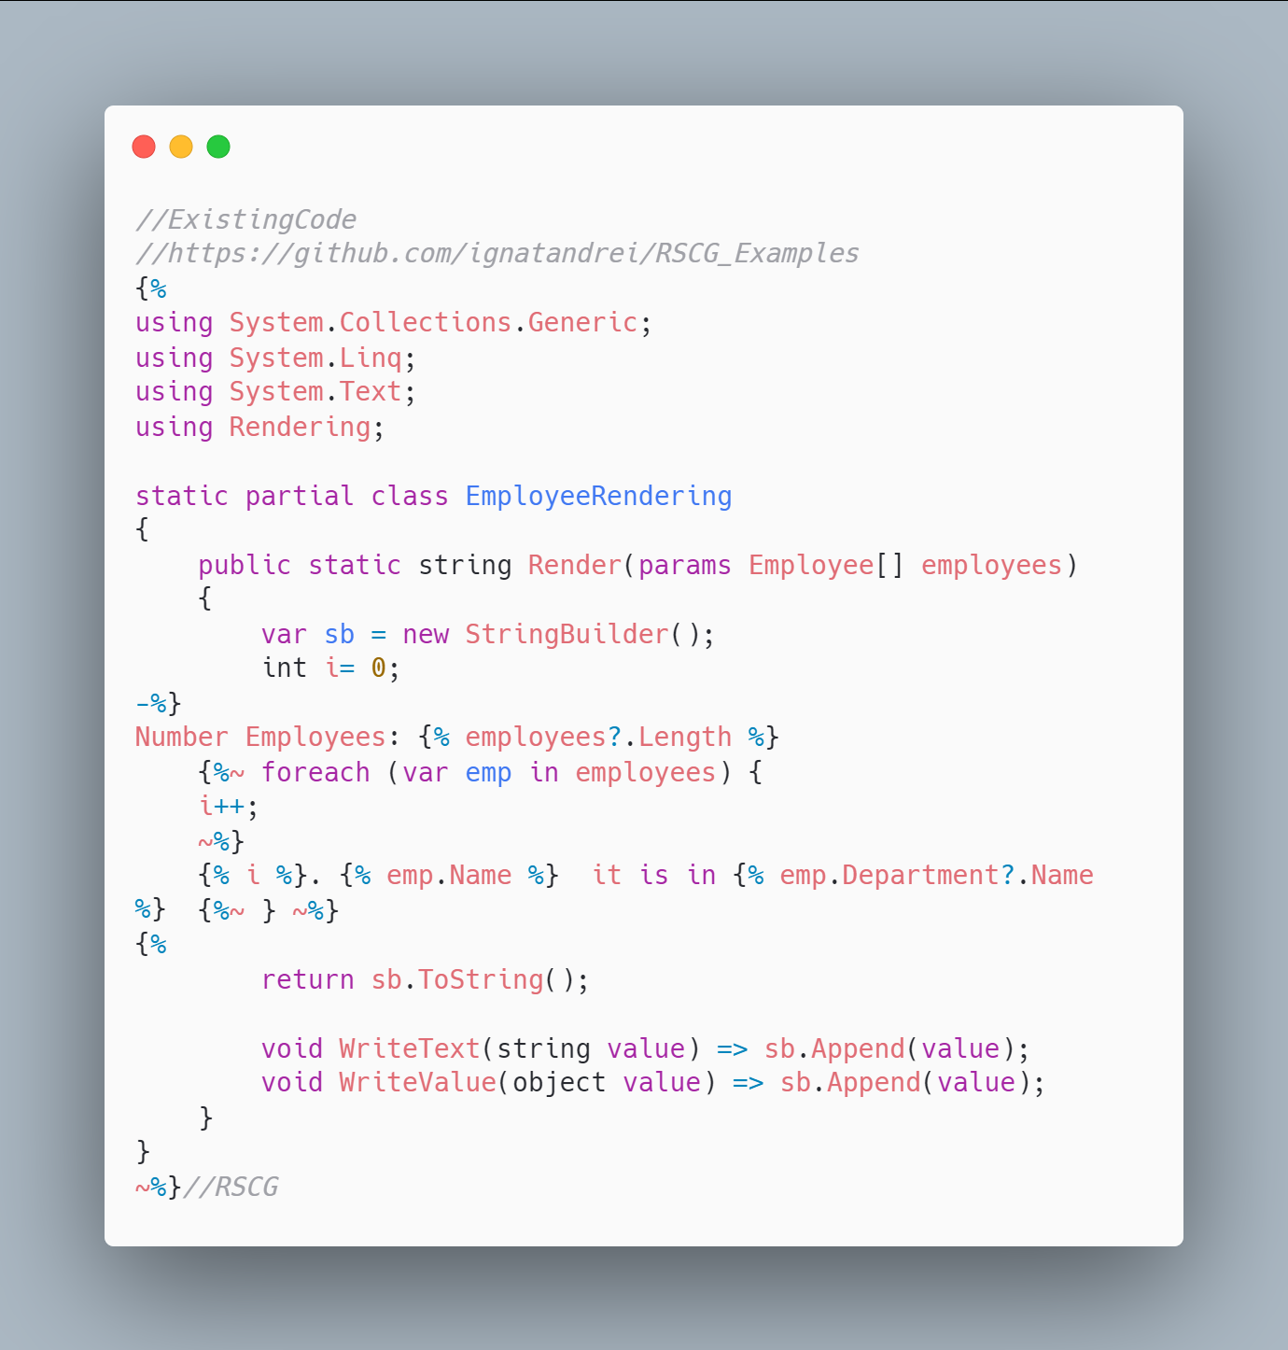 [code](http://ignatandrei.github.io/RSCG_Examples/images/Transplator/ExistingCode.cs)

#### The code below will use the RSCG Transplator

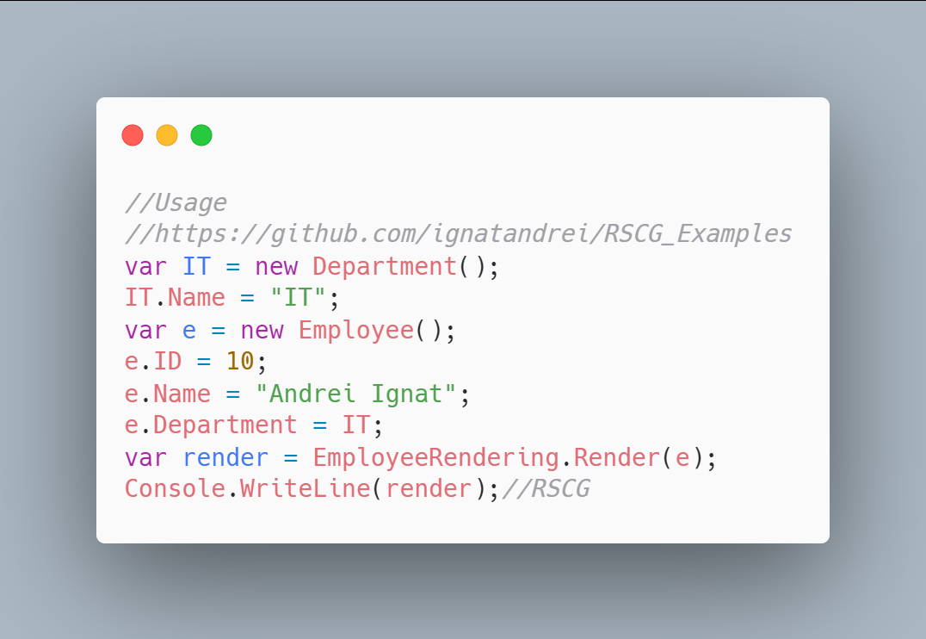 [code](http://ignatandrei.github.io/RSCG_Examples/images/Transplator/Usage.cs)

#### The code that is generated by RSCG Transplator

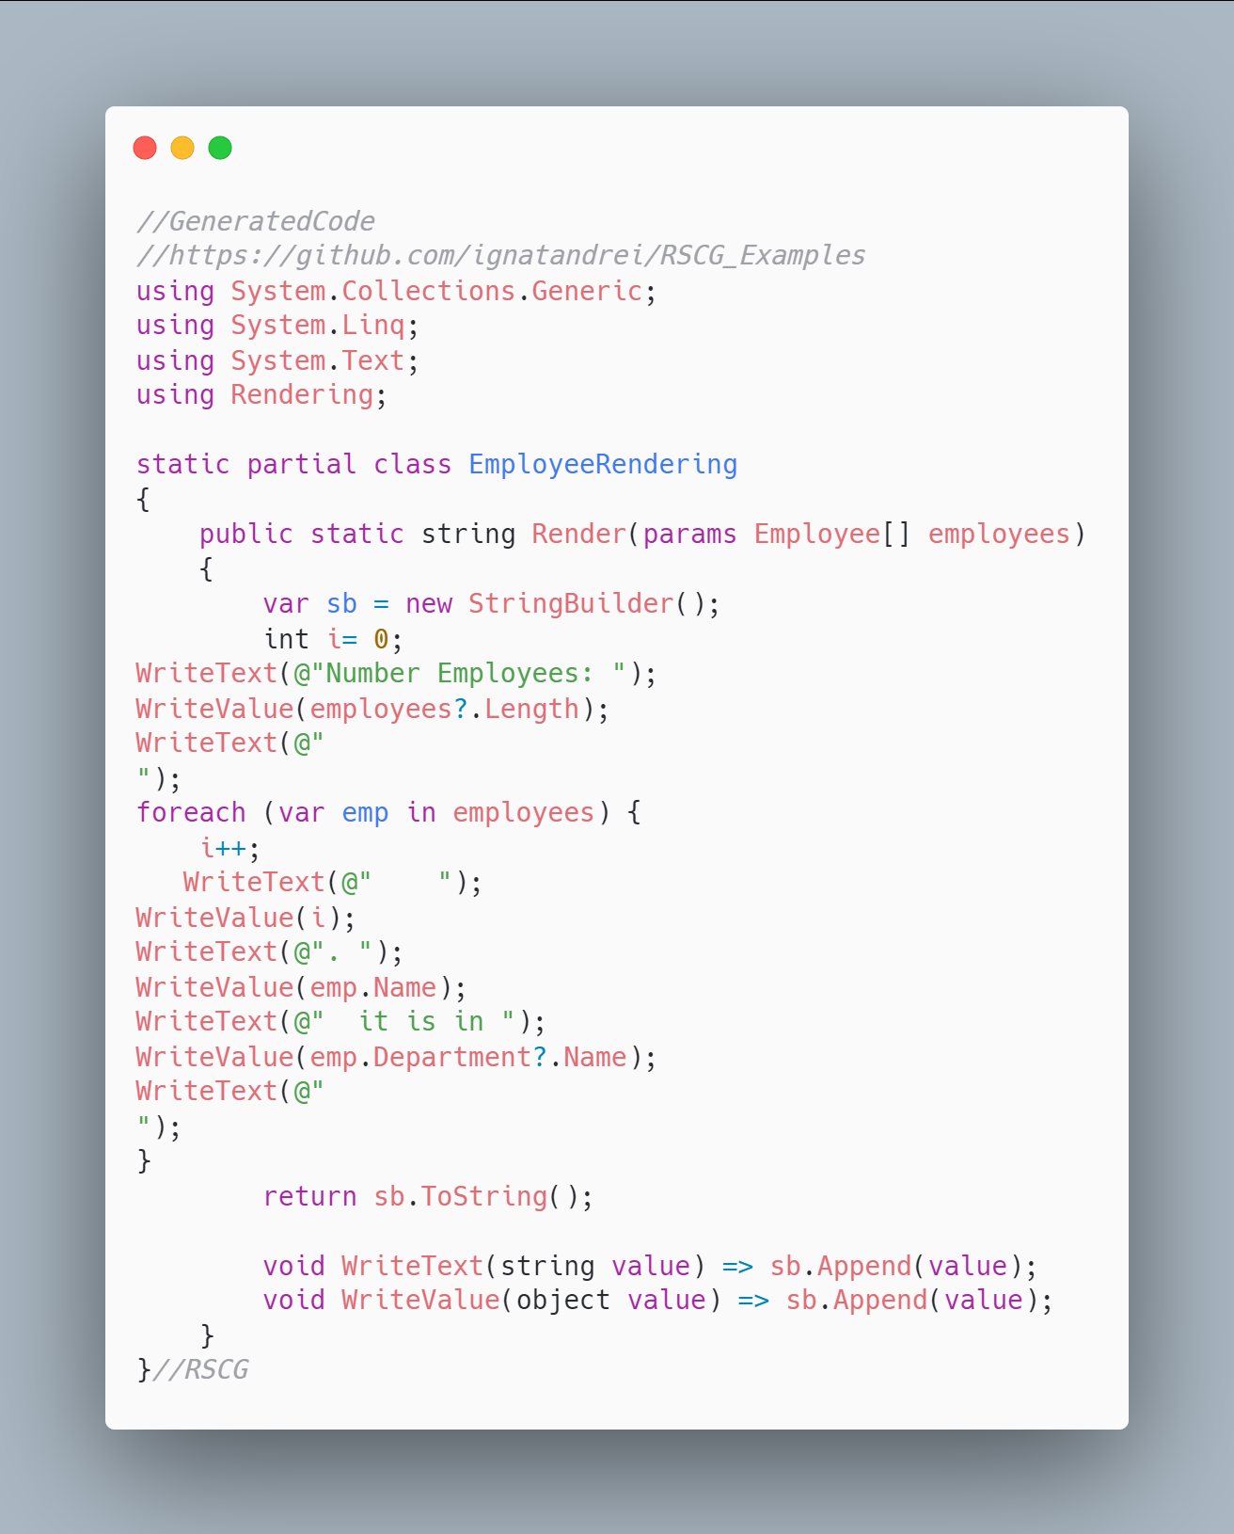 [code](http://ignatandrei.github.io/RSCG_Examples/images/Transplator/GeneratedCode.cs)

### More details about RSCG Transplator

The author of **RSCG Transplator** is *Atif Aziz*

You cand find **RSCG Transplator** at Nuget.org : <https://www.nuget.org/packages/Transplator/> and the sources at <https://github.com/atifaziz/Transplator/>

For more usage features please read : <https://github.com/atifaziz/Transplator/>

#### Link to Example Code:

[<https://github.com/ignatandrei/RSCG_Examples/tree/main/TemplateRender>](https://github.com/ignatandrei/RSCG_Examples/tree/main/TemplateRender)

## RSCG number 16 : RSCG_AMS

### What RSCG RSCG_AMS can do

The AMS will add in the CI the version and creator to your project.See <https://netcoreblockly.herokuapp.com/ams> for an example

### Example code

#### Here is the csproj with the references for RSCG RSCG_AMS

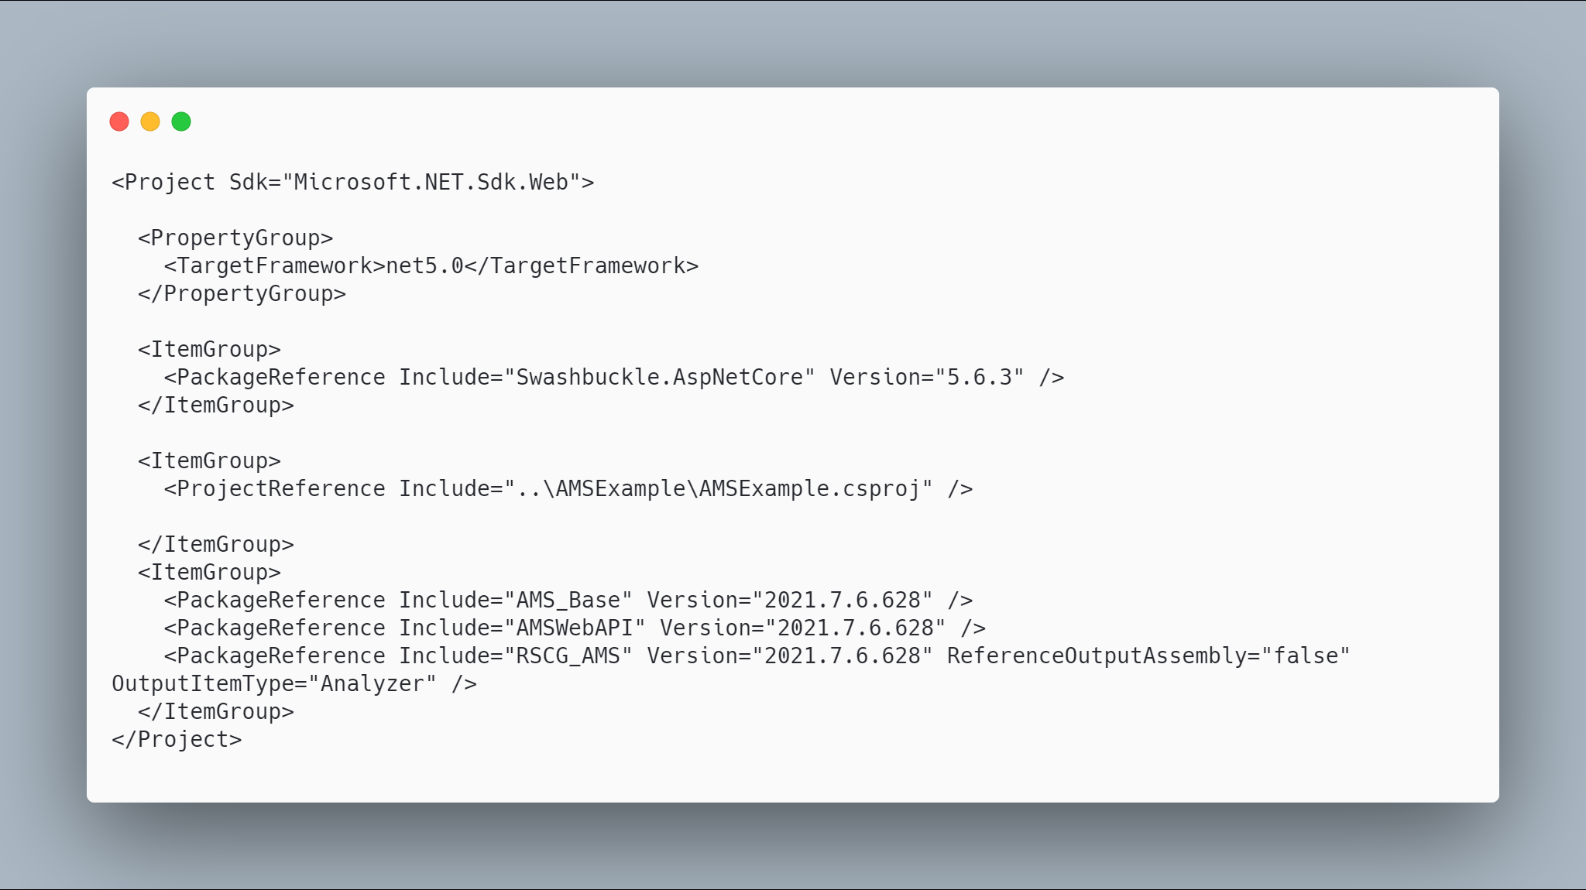 [code](http://ignatandrei.github.io/RSCG_Examples/images/RSCG_AMS/The.csproj)

#### The initial code that you start with is

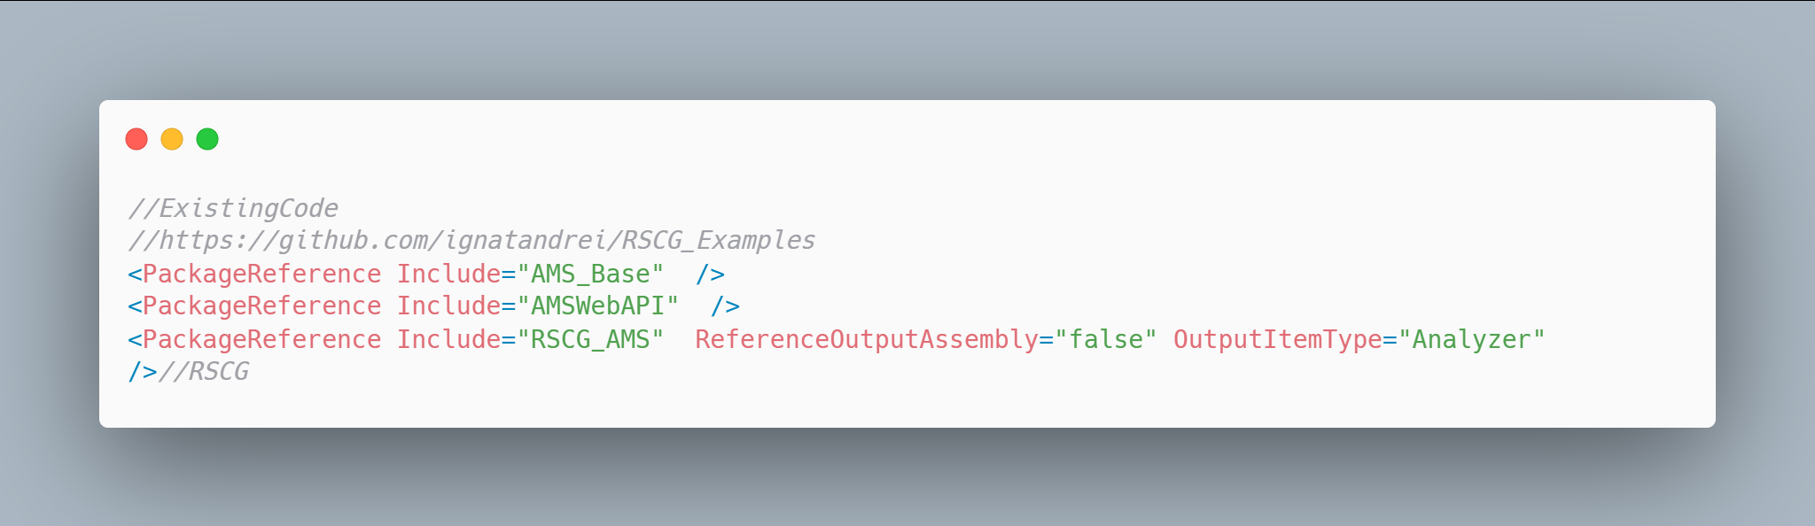 [code](http://ignatandrei.github.io/RSCG_Examples/images/RSCG_AMS/ExistingCode.cs)

#### The code below will use the RSCG RSCG_AMS

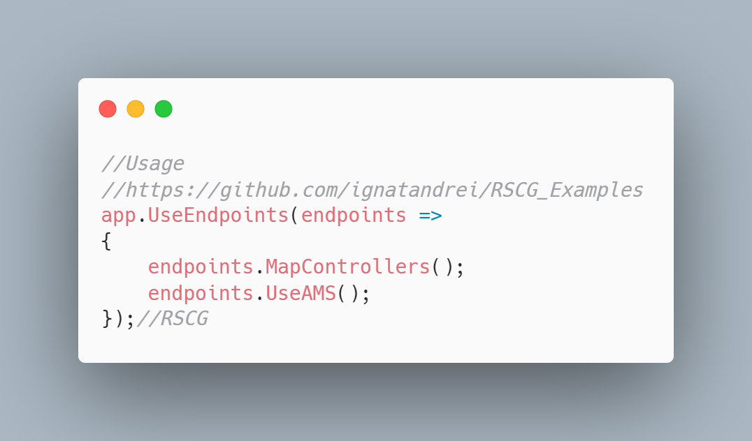 [code](http://ignatandrei.github.io/RSCG_Examples/images/RSCG_AMS/Usage.cs)

#### The code that is generated by RSCG RSCG_AMS

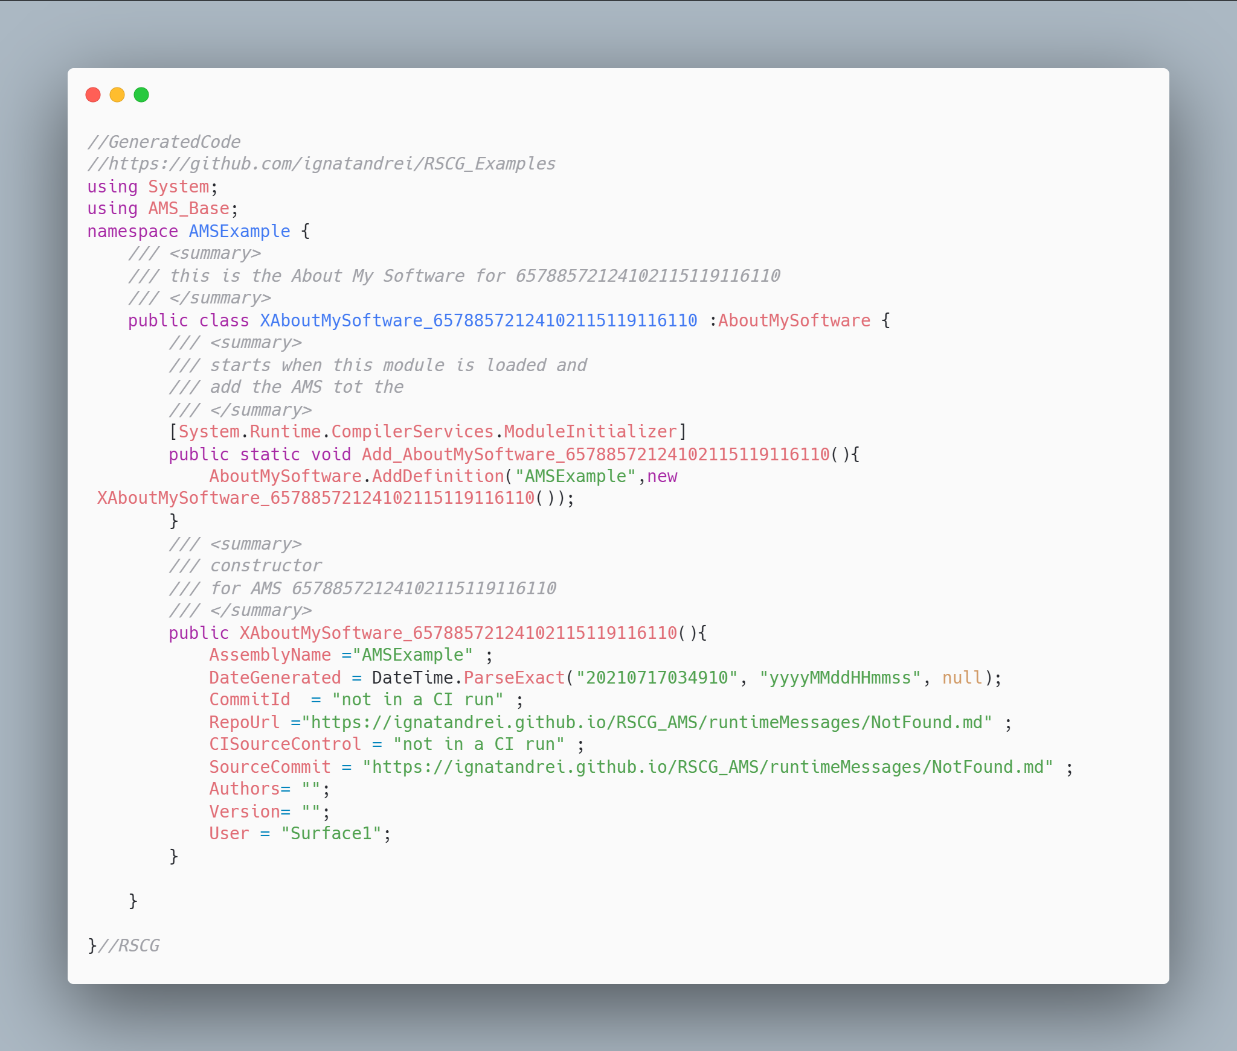 [code](http://ignatandrei.github.io/RSCG_Examples/images/RSCG_AMS/GeneratedCode.cs)

### More details about RSCG RSCG_AMS

The author of **RSCG RSCG_AMS** is *Andrei Ignat*

You cand find **RSCG RSCG_AMS** at Nuget.org : <https://www.nuget.org/packages/AMS_Base> <https://www.nuget.org/packages/AMSWebAPI> <https://www.nuget.org/packages/RSCG_AMS> and the sources at <https://github.com/ignatandrei/RSCG_AMS>

For more usage features please read : <https://github.com/ignatandrei/RSCG_AMS>

#### Link to Example Code:

[<https://github.com/ignatandrei/RSCG_Examples/tree/main/CI_Version>](https://github.com/ignatandrei/RSCG_Examples/tree/main/CI_Version)

## RSCG number 17 : HttpClientGenerator

### What RSCG HttpClientGenerator can do

HttpClientGenerator is a tool that uses Roslyn code generator feature to write boilerplate HttpClient code for you.

### Example code

#### Here is the csproj with the references for RSCG HttpClientGenerator

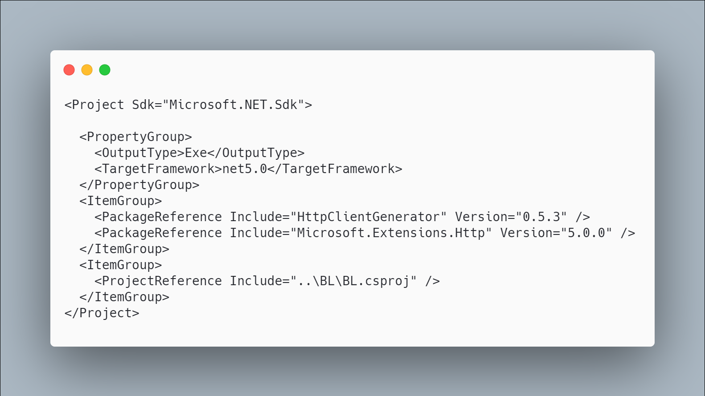 [code](http://ignatandrei.github.io/RSCG_Examples/images/HttpClientGenerator/The.csproj)

#### The initial code that you start with is

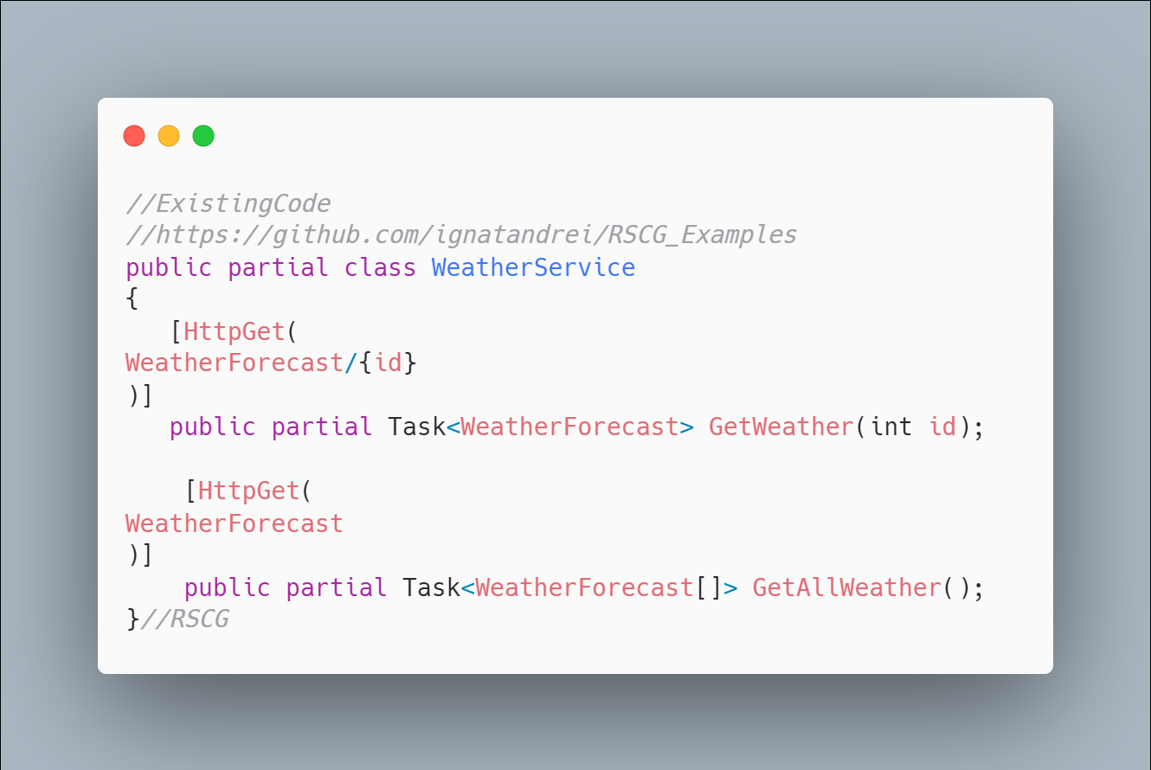 [code](http://ignatandrei.github.io/RSCG_Examples/images/HttpClientGenerator/ExistingCode.cs)

#### The code below will use the RSCG HttpClientGenerator

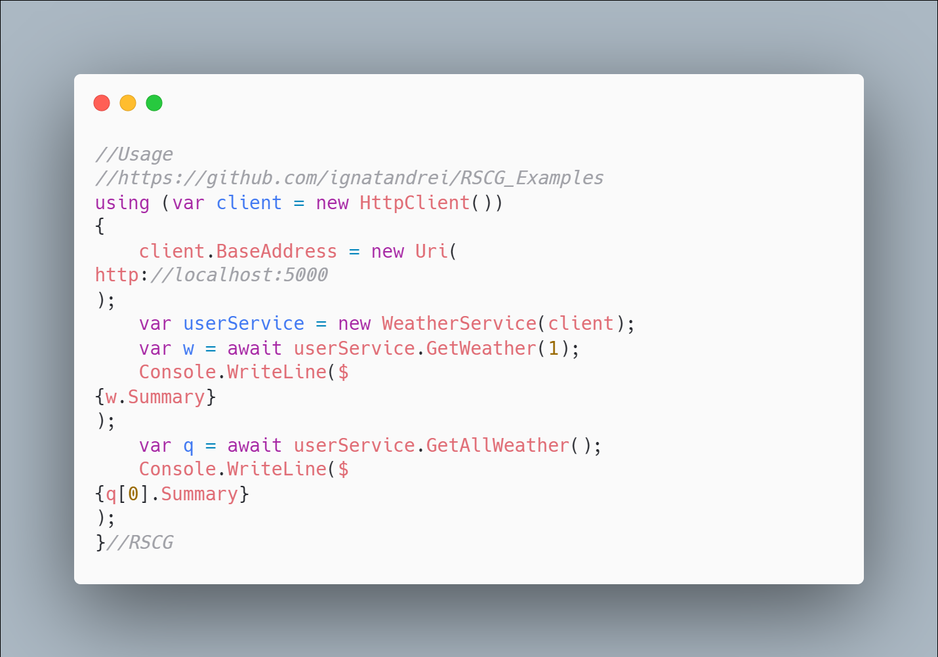 [code](http://ignatandrei.github.io/RSCG_Examples/images/HttpClientGenerator/Usage.cs)

#### The code that is generated by RSCG HttpClientGenerator

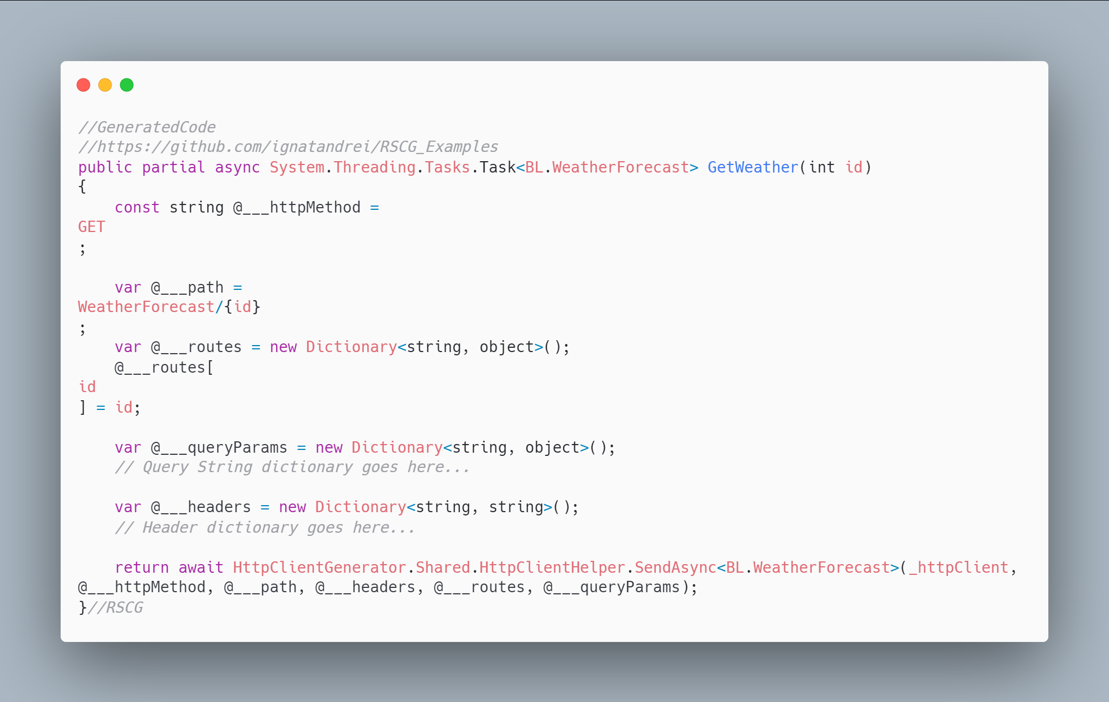 [code](http://ignatandrei.github.io/RSCG_Examples/images/HttpClientGenerator/GeneratedCode.cs)

### More details about RSCG HttpClientGenerator

The author of **RSCG HttpClientGenerator** is *Jalal Amini Robati*

You cand find **RSCG HttpClientGenerator** at Nuget.org : <https://www.nuget.org/packages/HttpClientGenerator/> and the sources at <https://github.com/Jalalx/HttpClientCodeGenerator>

For more usage features please read : <https://github.com/Jalalx/HttpClientCodeGenerator>

#### Link to Example Code:

[<https://github.com/ignatandrei/RSCG_Examples/tree/main/HttpClientCodeGenerator>](https://github.com/ignatandrei/RSCG_Examples/tree/main/HttpClientCodeGenerator)

### Author of HttpClientGenerator , Jalal Amini Robati

1. Short info about you , Jalal Amini Robati

I am working as a senior software engineer at Alibaba Travels.

1. Why did you start this HttpClientGenerator ?

I built HttpClientGenerator to help users stop writing HttpClient code. Currently, some users use tools like swaggergen which generates too much code that is hard to maintain.

1. How do yourself use your HttpClientGenerator ?

I am going to use it in a high-traffic website on production when it gets mature enough. I mostly use it on my personal projects and look for feedback from developers for now.

1. What other RSCG do you use ?

Since the RSCG is in the early stages, I don't know that many tools but I think it can be applied to many areas like DI, ORMs. Currently Dapper.AOT is using this feature that would make writing database code so much faster.

## RSCG number 18 : DatabaseToWebAPI

### What RSCG DatabaseToWebAPI can do

This will generate code (WebAPI/Swagger) for any table/view from SqlServer. You can see the table via Angular

### Example code

#### Here is the csproj with the references for RSCG DatabaseToWebAPI

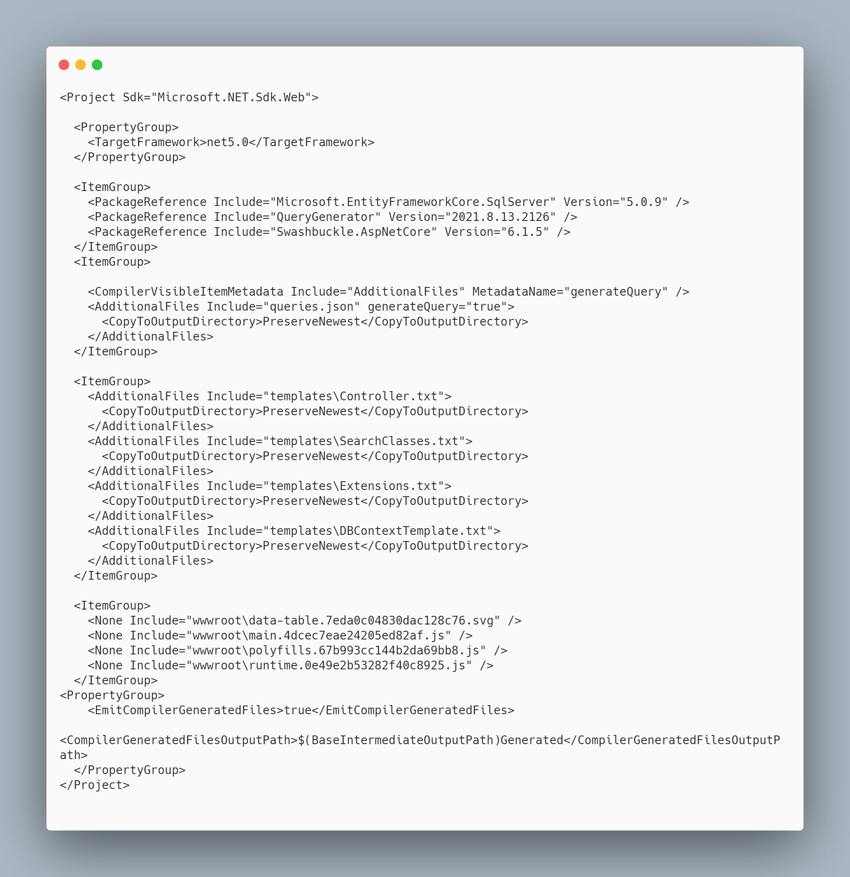 [code](http://ignatandrei.github.io/RSCG_Examples/images/DatabaseToWebAPI/The.csproj)

#### The initial code that you start with is

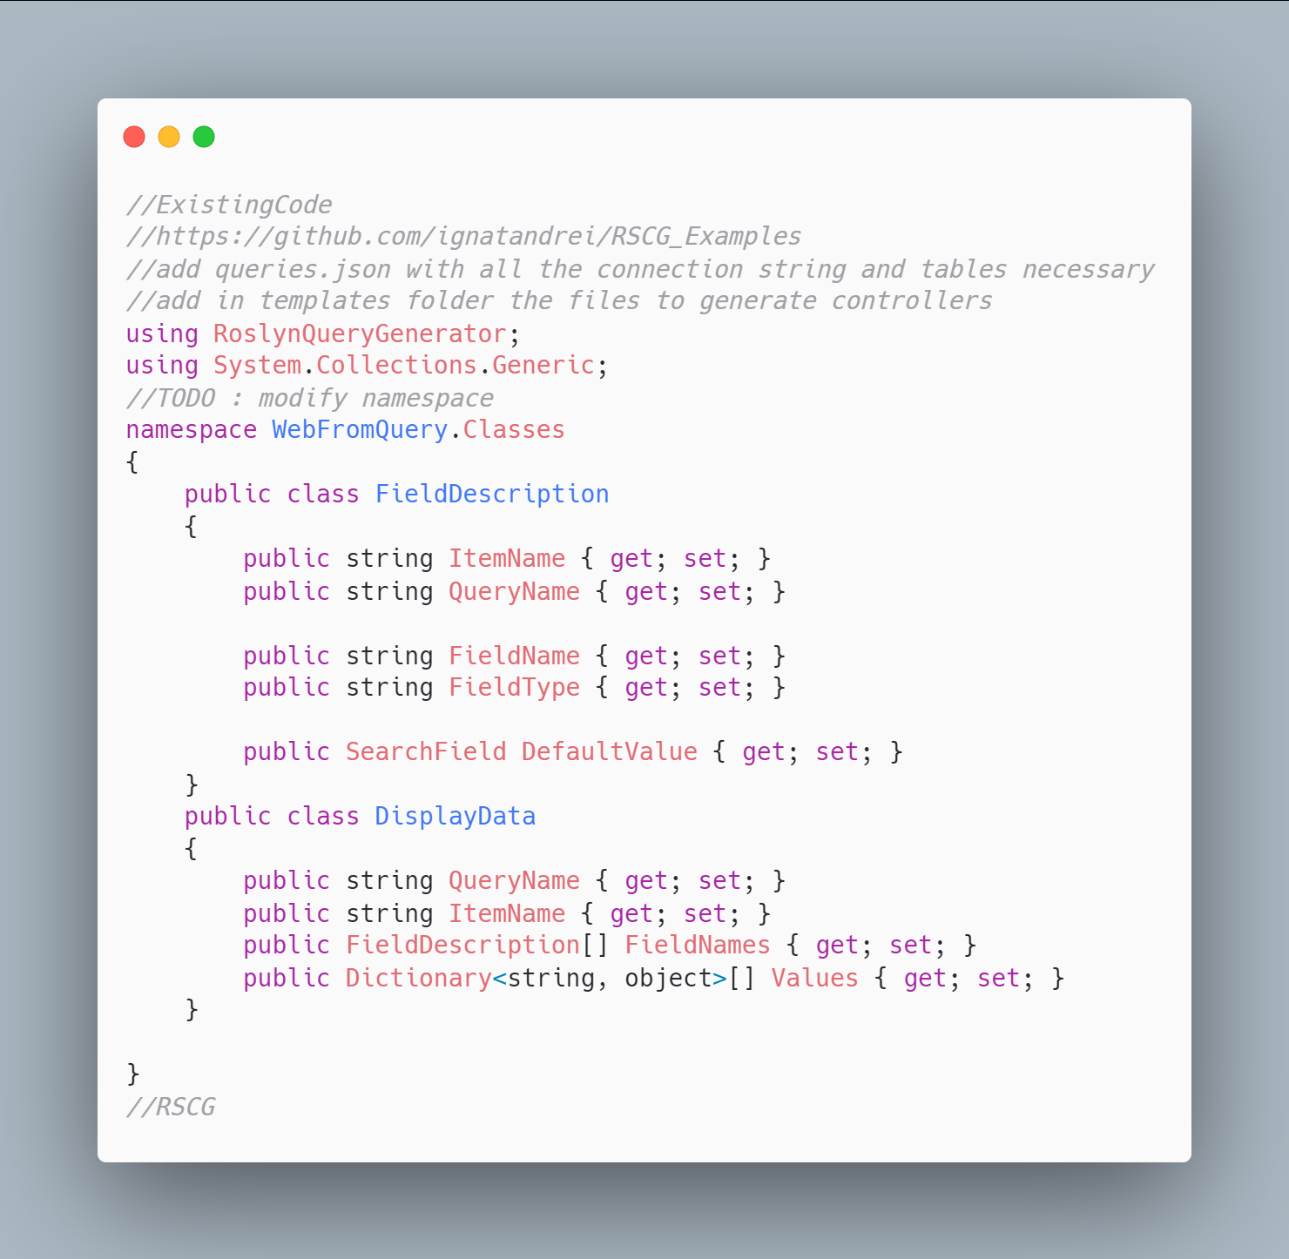 [code](http://ignatandrei.github.io/RSCG_Examples/images/DatabaseToWebAPI/ExistingCode.cs)

#### The code below will use the RSCG DatabaseToWebAPI

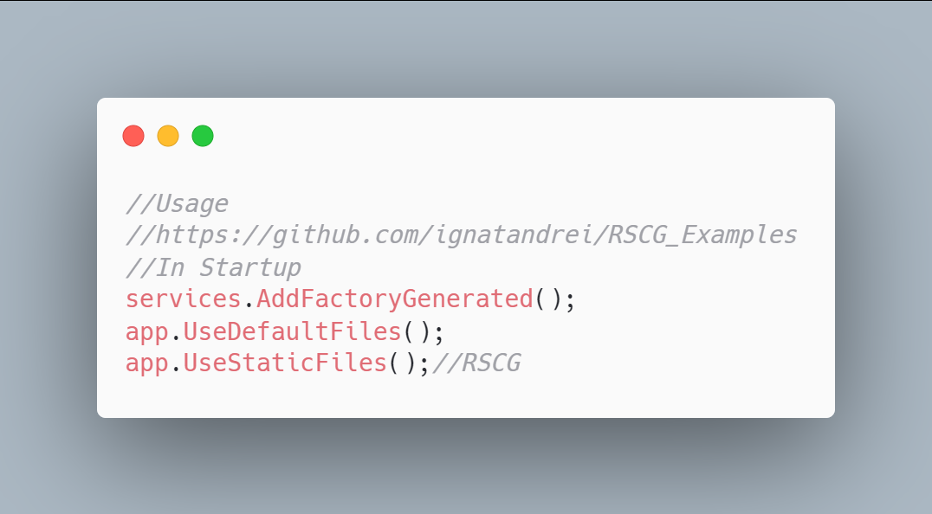 [code](http://ignatandrei.github.io/RSCG_Examples/images/DatabaseToWebAPI/Usage.cs)

#### The code that is generated by RSCG DatabaseToWebAPI

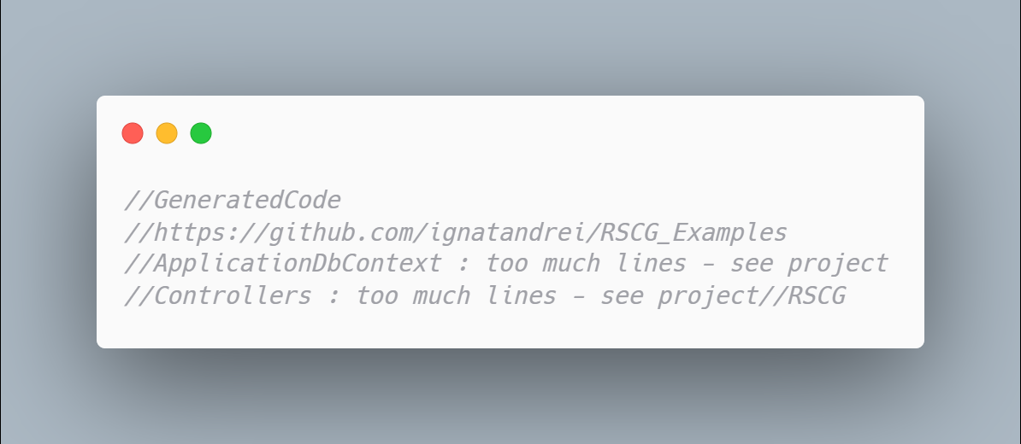 [code](http://ignatandrei.github.io/RSCG_Examples/images/DatabaseToWebAPI/GeneratedCode.cs)

### More details about RSCG DatabaseToWebAPI

The author of **RSCG DatabaseToWebAPI** is *Andrei Ignat*

You cand find **RSCG DatabaseToWebAPI** at Nuget.org : <https://www.nuget.org/packages/QueryGenerator/> and the sources at <https://github.com/ignatandrei/QueryViewer/>

For more usage features please read : <http://msprogrammer.serviciipeweb.ro/category/roslyn/>

#### Link to Example Code:

[<https://github.com/ignatandrei/RSCG_Examples/tree/main/QueryGenerator>](https://github.com/ignatandrei/RSCG_Examples/tree/main/QueryGenerator)

## RSCG number 19 : SourceInject

### What RSCG SourceInject can do

Auto register services in startup

### Example code

#### Here is the csproj with the references for RSCG SourceInject

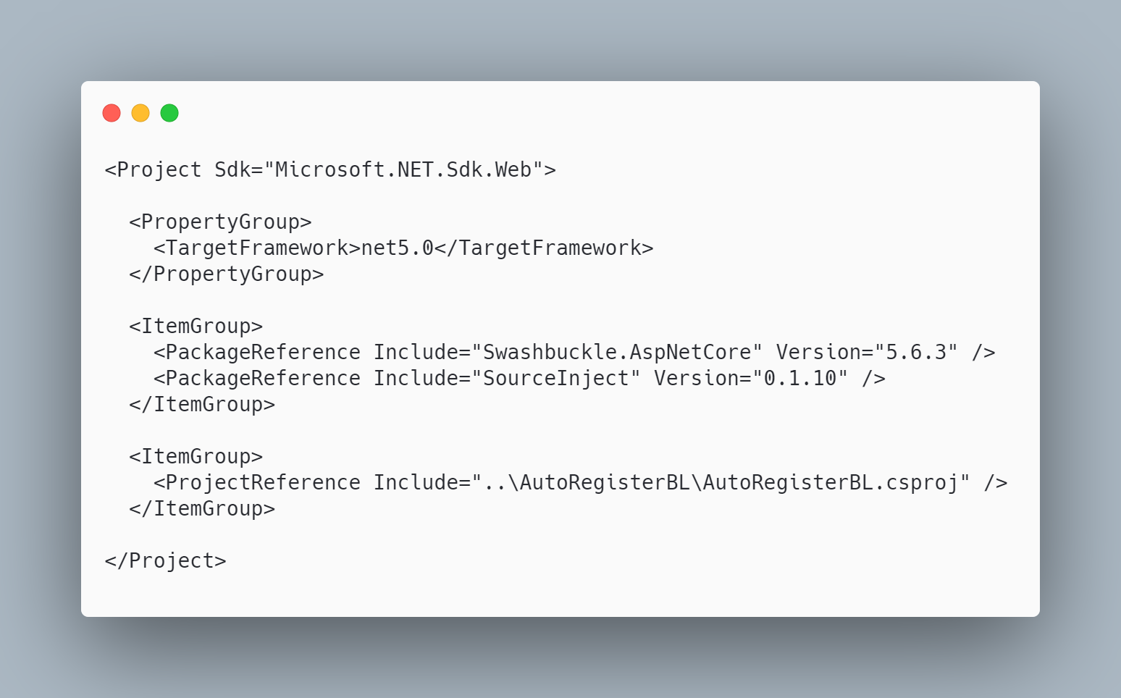 [code](http://ignatandrei.github.io/RSCG_Examples/images/SourceInject/The.csproj)

#### The initial code that you start with is

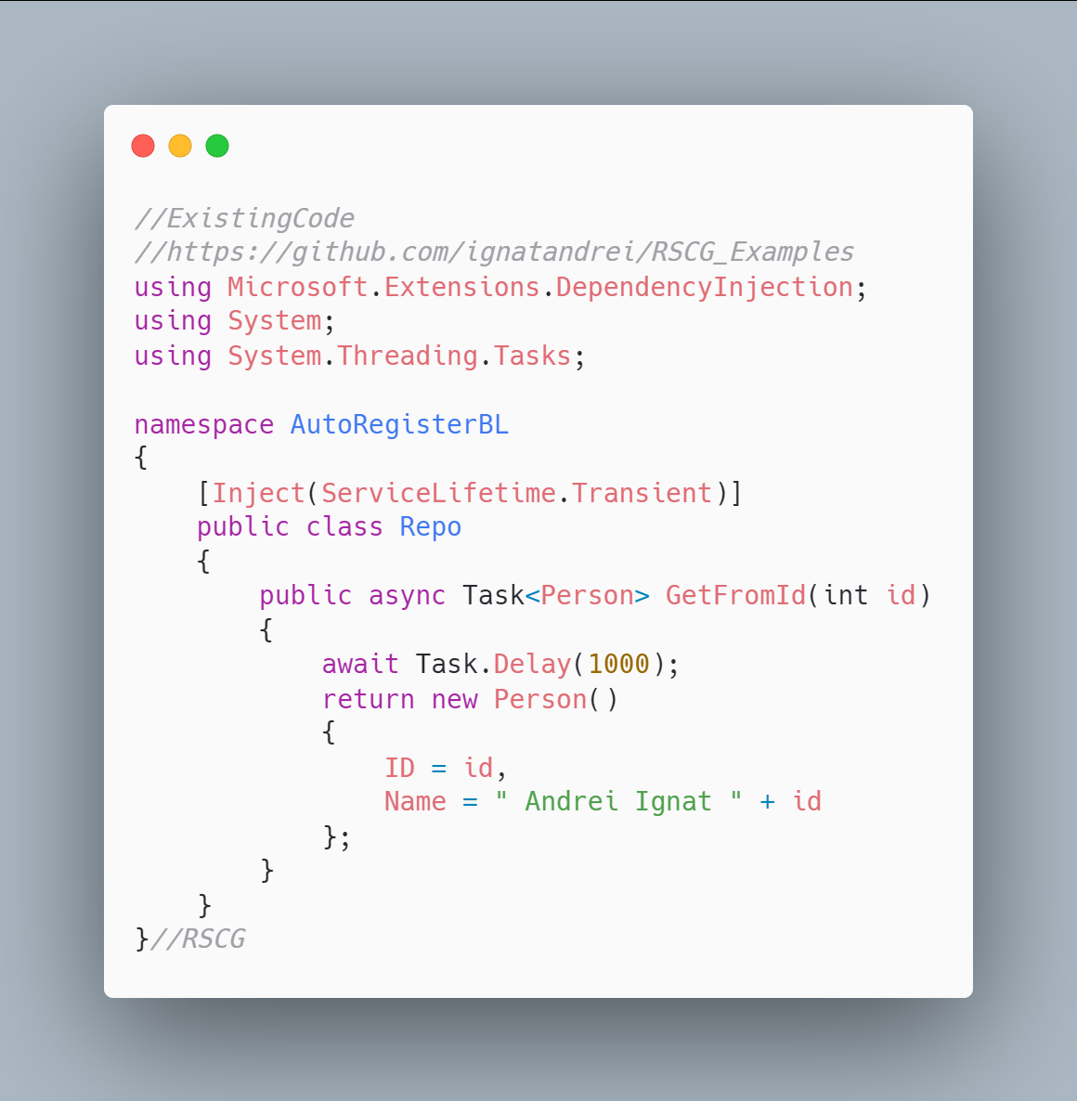 [code](http://ignatandrei.github.io/RSCG_Examples/images/SourceInject/ExistingCode.cs)

#### The code below will use the RSCG SourceInject

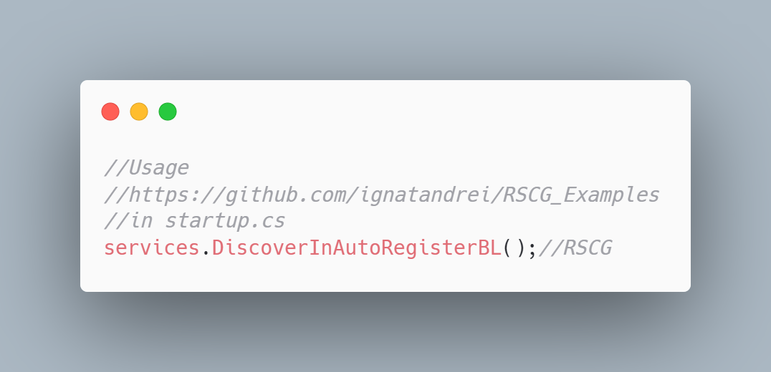 [code](http://ignatandrei.github.io/RSCG_Examples/images/SourceInject/Usage.cs)

#### The code that is generated by RSCG SourceInject

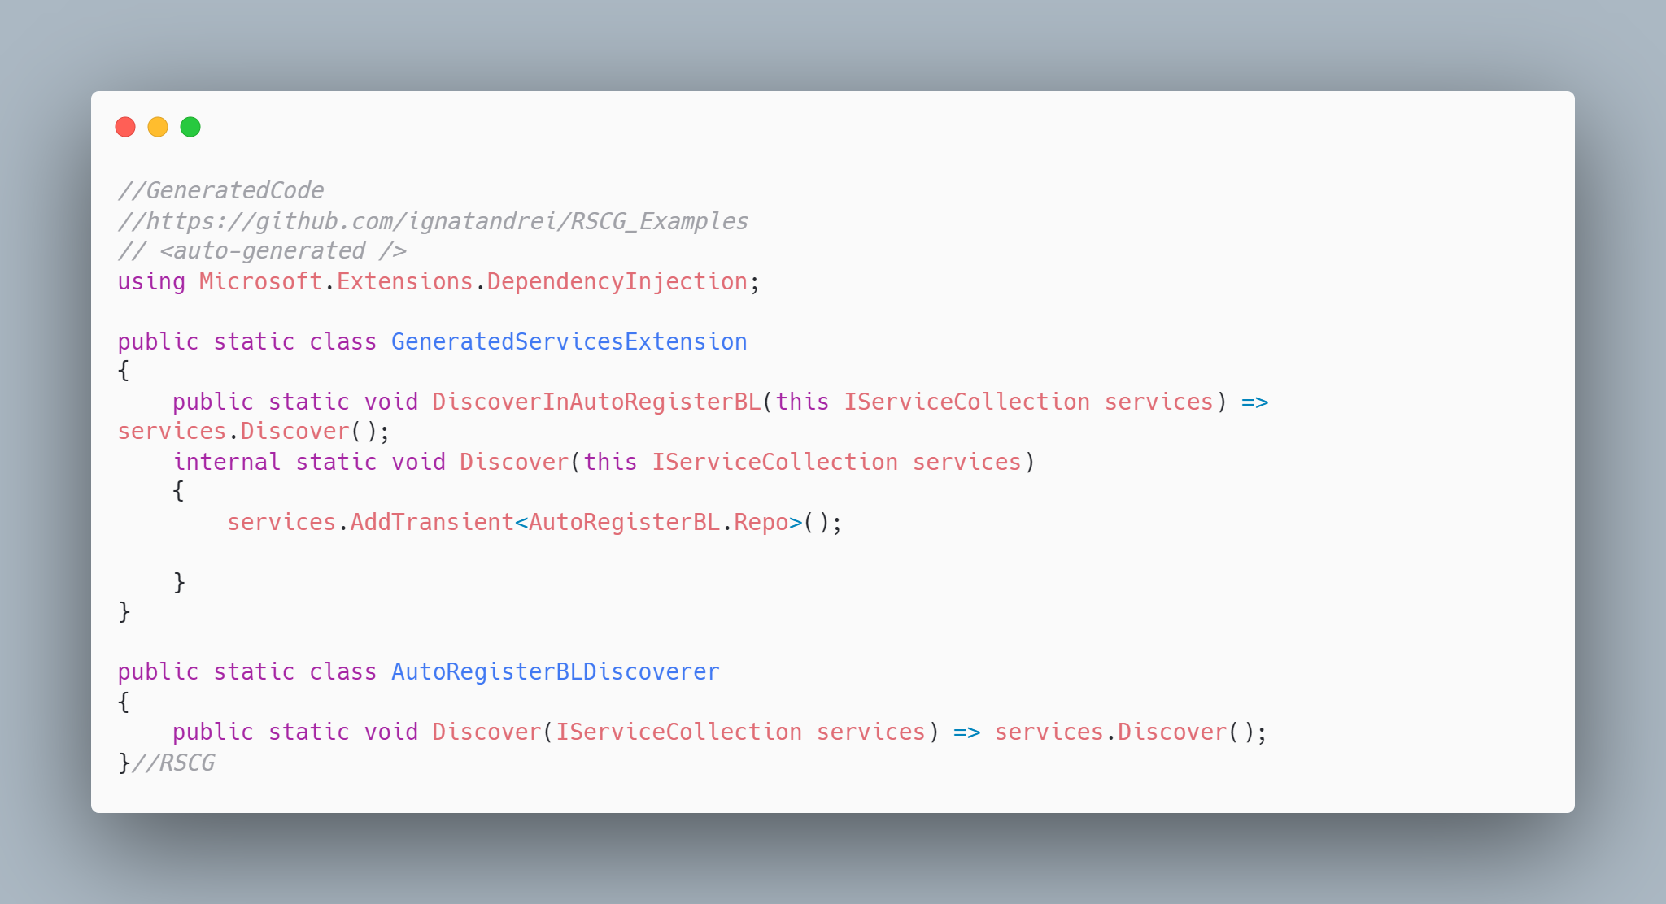 [code](http://ignatandrei.github.io/RSCG_Examples/images/SourceInject/GeneratedCode.cs)

### More details about RSCG SourceInject

The author of **RSCG SourceInject** is *Giovanni Bassi*

You cand find **RSCG SourceInject** at Nuget.org : <https://www.nuget.org/packages/SourceInject/> and the sources at <https://github.com/giggio/sourceinject>

For more usage features please read : <https://github.com/giggio/sourceinject>

#### Link to Example Code:

[<https://github.com/ignatandrei/RSCG_Examples/tree/main/AutoRegister>](https://github.com/ignatandrei/RSCG_Examples/tree/main/AutoRegister)

## RSCG number 21 : BaseTypes

### What RSCG BaseTypes can do

Generated tiny types from any value type

### Example code

#### Here is the csproj with the references for RSCG BaseTypes

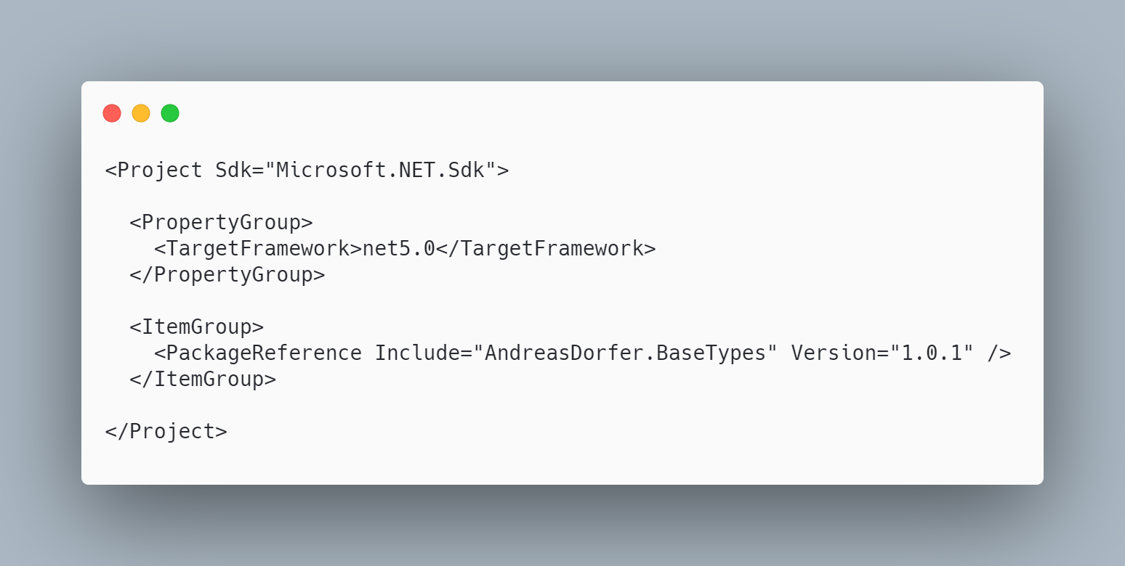 [code](http://ignatandrei.github.io/RSCG_Examples/images/BaseTypes/The.csproj)

#### The initial code that you start with is

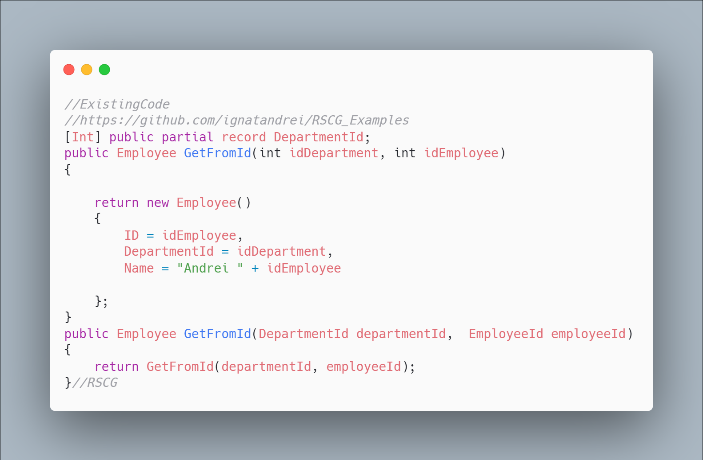 [code](http://ignatandrei.github.io/RSCG_Examples/images/BaseTypes/ExistingCode.cs)

#### The code below will use the RSCG BaseTypes

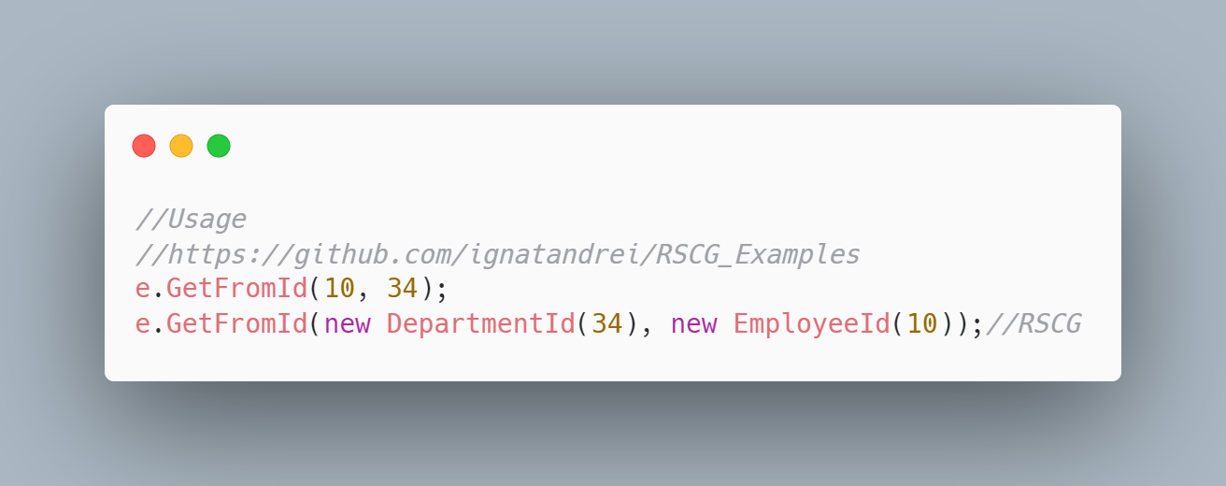 [code](http://ignatandrei.github.io/RSCG_Examples/images/BaseTypes/Usage.cs)

#### The code that is generated by RSCG BaseTypes

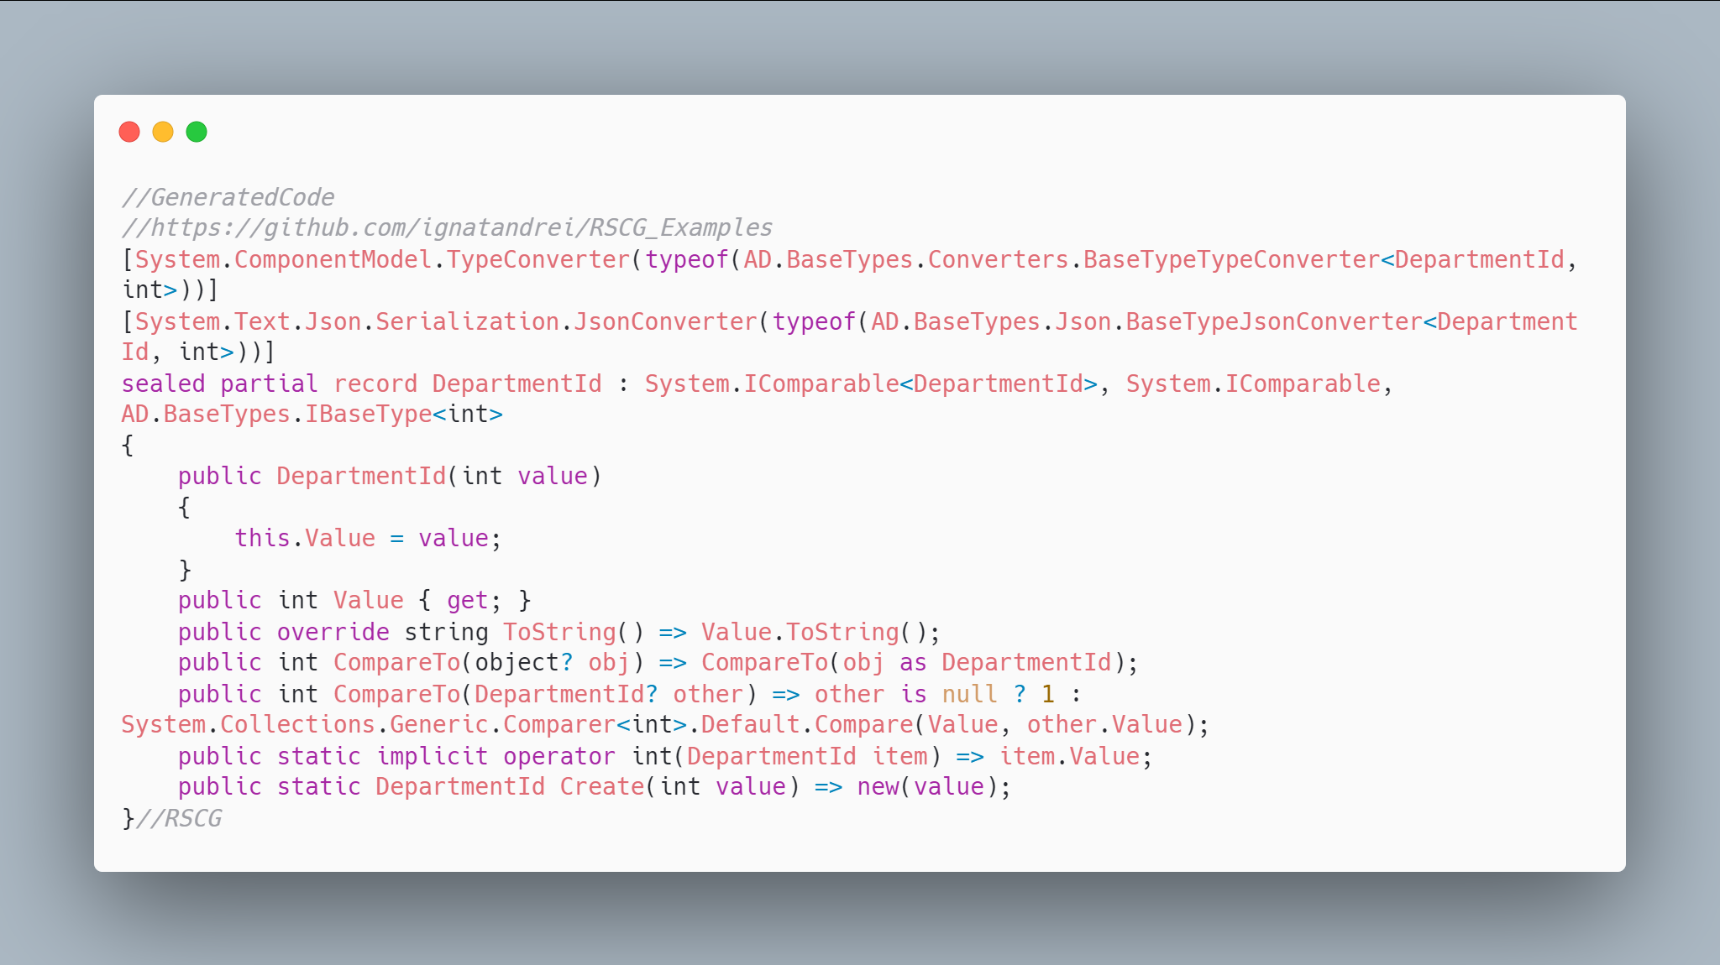 [code](http://ignatandrei.github.io/RSCG_Examples/images/BaseTypes/GeneratedCode.cs)

### More details about RSCG BaseTypes

The author of **RSCG BaseTypes** is *Andreas Dorfer*

You cand find **RSCG BaseTypes** at Nuget.org : <https://www.nuget.org/packages/AndreasDorfer.BaseTypes/> and the sources at <https://github.com/Andreas-Dorfer/base-types>

For more usage features please read : <https://github.com/Andreas-Dorfer/base-types>

#### Link to Example Code:

[<https://github.com/ignatandrei/RSCG_Examples/tree/main/TinyTypes>](https://github.com/ignatandrei/RSCG_Examples/tree/main/TinyTypes)

## RSCG number 22 : AppSettingsEditor

### What RSCG AppSettingsEditor can do

This will generate classes code from appsettings . Additionally , it generates API controller for editing and an UI interface

### Example code

#### Here is the csproj with the references for RSCG AppSettingsEditor

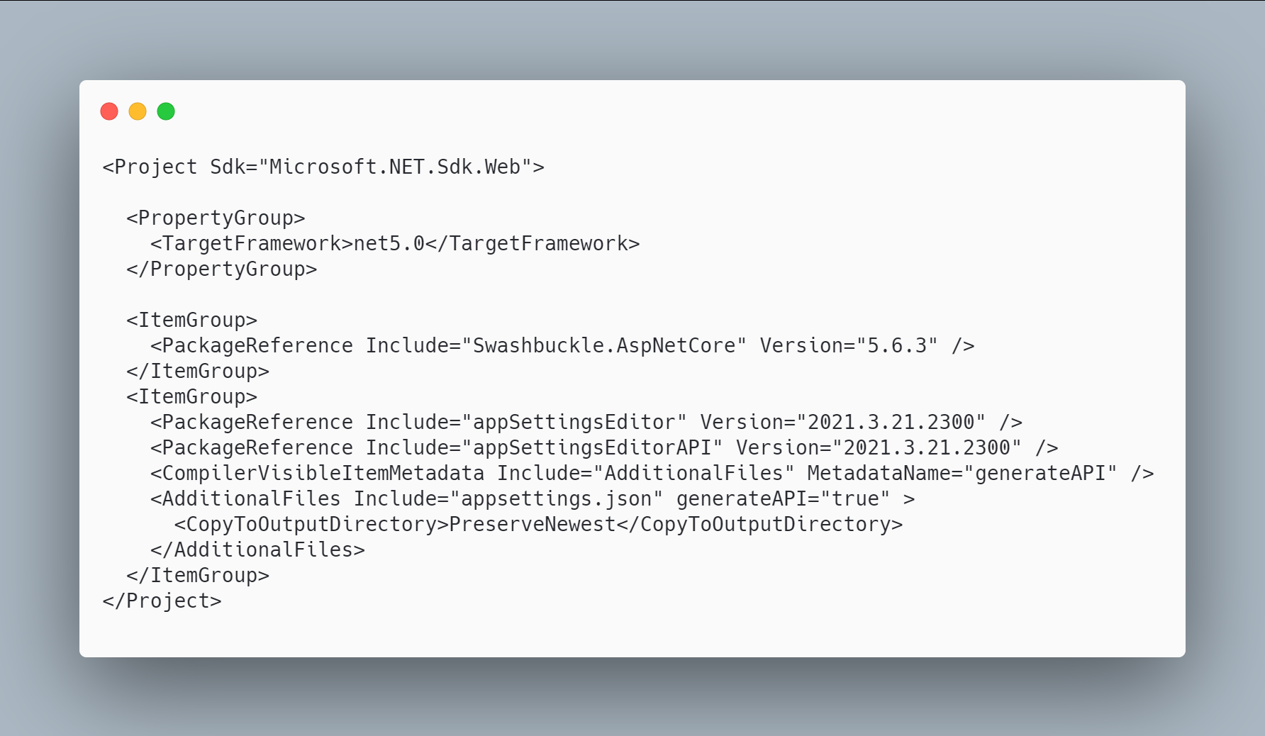 [code](http://ignatandrei.github.io/RSCG_Examples/images/AppSettingsEditor/The.csproj)

#### The initial code that you start with is

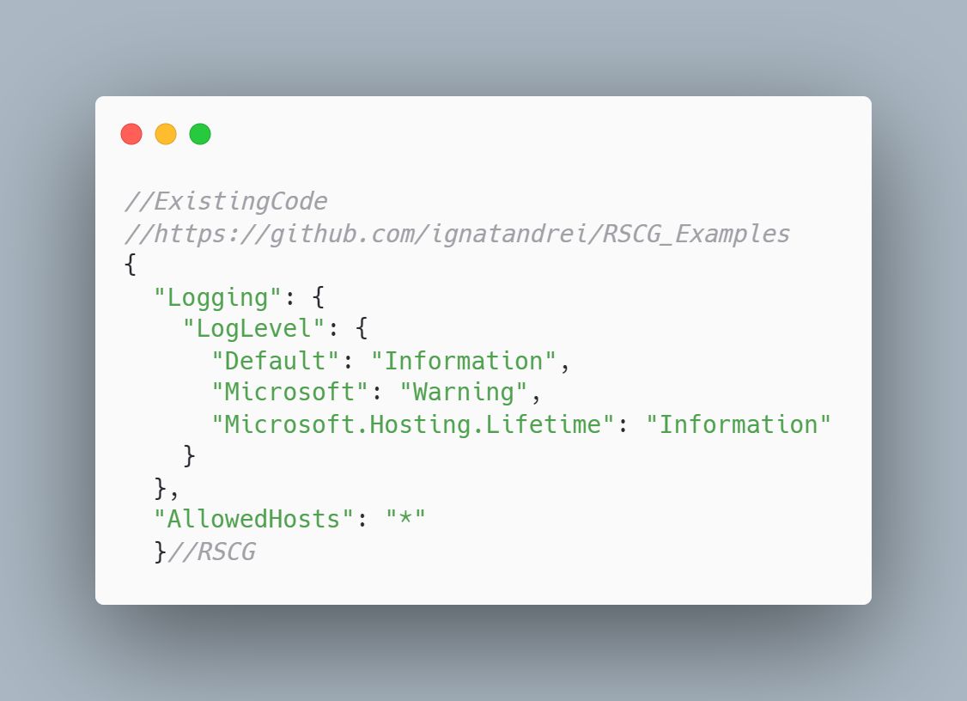 [code](http://ignatandrei.github.io/RSCG_Examples/images/AppSettingsEditor/ExistingCode.cs)

#### The code below will use the RSCG AppSettingsEditor

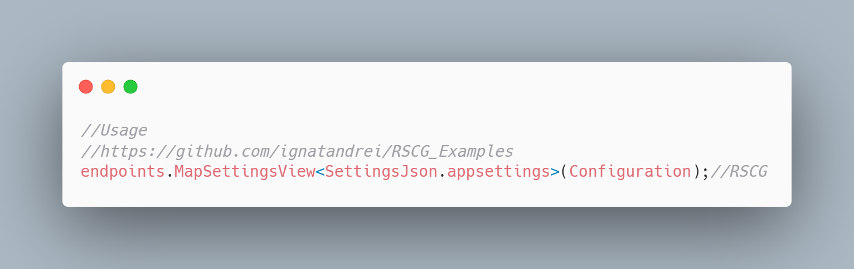 [code](http://ignatandrei.github.io/RSCG_Examples/images/AppSettingsEditor/Usage.cs)

#### The code that is generated by RSCG AppSettingsEditor

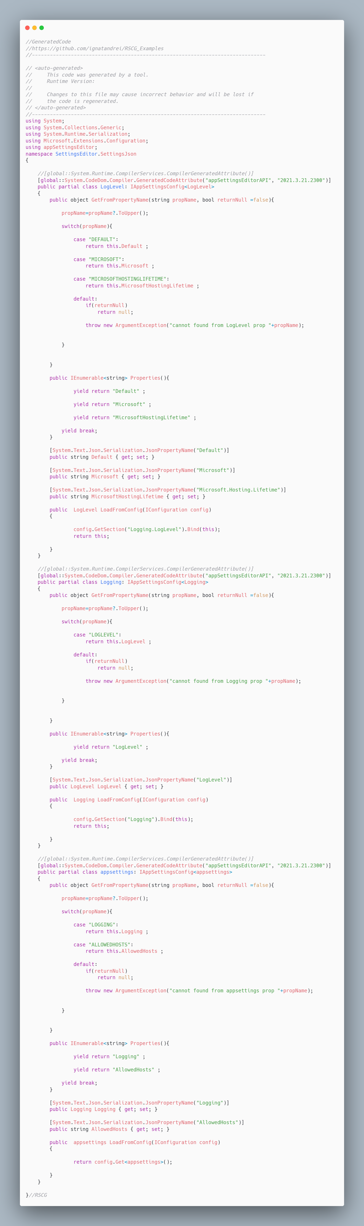 [code](http://ignatandrei.github.io/RSCG_Examples/images/AppSettingsEditor/GeneratedCode.cs)

### More details about RSCG AppSettingsEditor

The author of **RSCG AppSettingsEditor** is *Andrei Ignat*

You cand find **RSCG AppSettingsEditor** at Nuget.org : <https://www.nuget.org/packages/appSettingsEditor/> and the sources at <https://github.com/ignatandrei/appSettingsEditor>

For more usage features please read : <http://msprogrammer.serviciipeweb.ro/category/roslyn/>

#### Link to Example Code:

[<https://github.com/ignatandrei/RSCG_Examples/tree/main/appSettingsEditor>](https://github.com/ignatandrei/RSCG_Examples/tree/main/appSettingsEditor)

## RSCG number 23 : ApparatusAOT

### What RSCG ApparatusAOT can do

This will generate code for investigating at runtime the properties of an object

### Example code

#### Here is the csproj with the references for RSCG ApparatusAOT

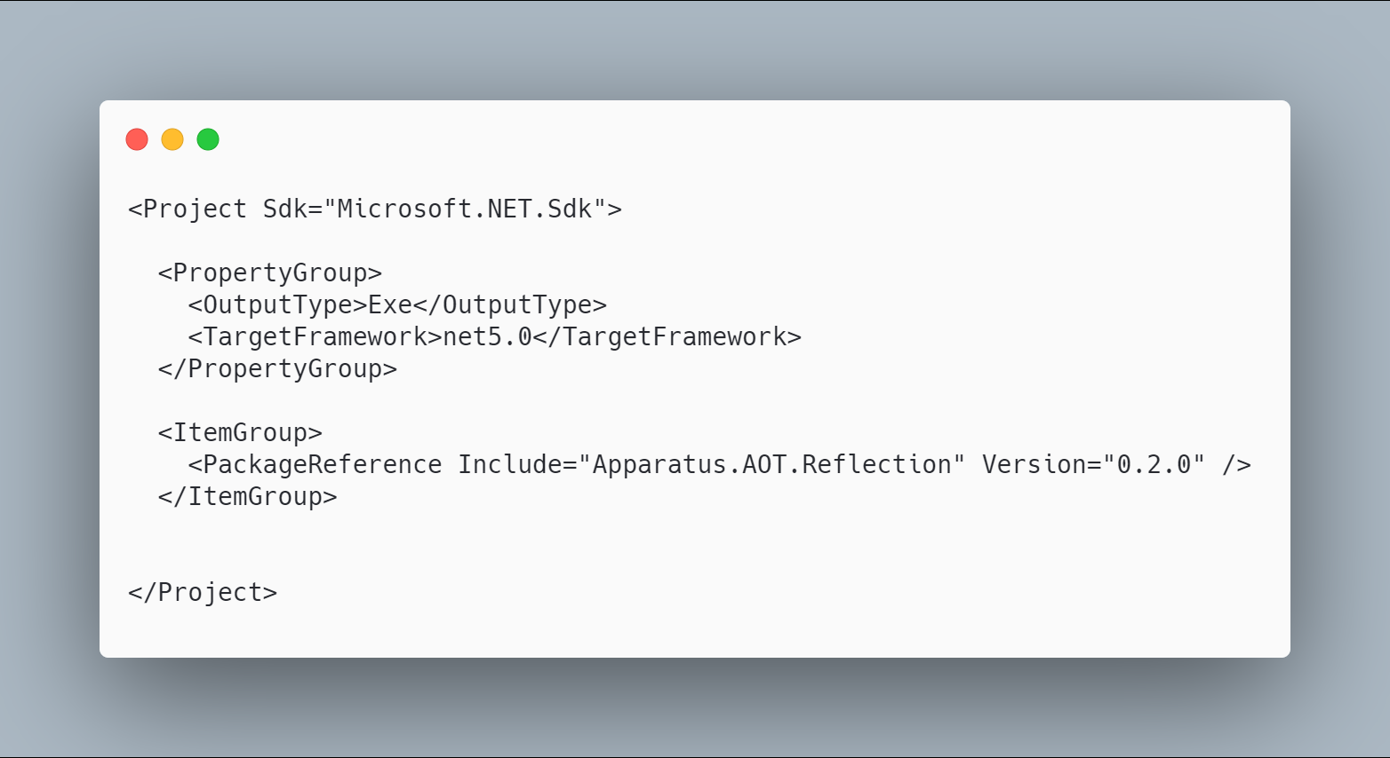 [code](http://ignatandrei.github.io/RSCG_Examples/images/ApparatusAOT/The.csproj)

#### The initial code that you start with is

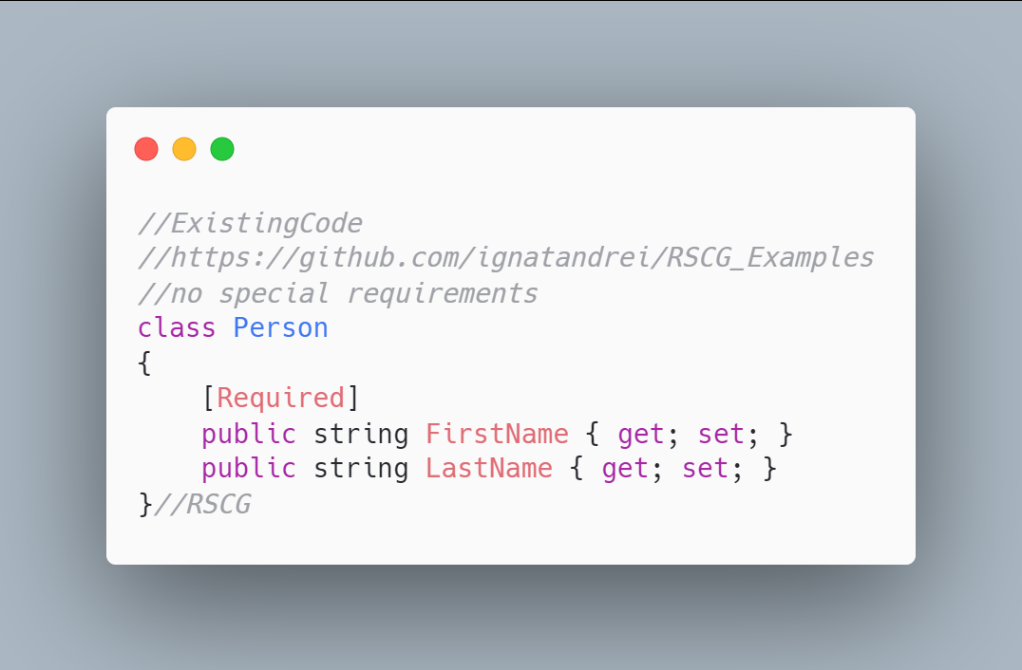 [code](http://ignatandrei.github.io/RSCG_Examples/images/ApparatusAOT/ExistingCode.cs)

#### The code below will use the RSCG ApparatusAOT

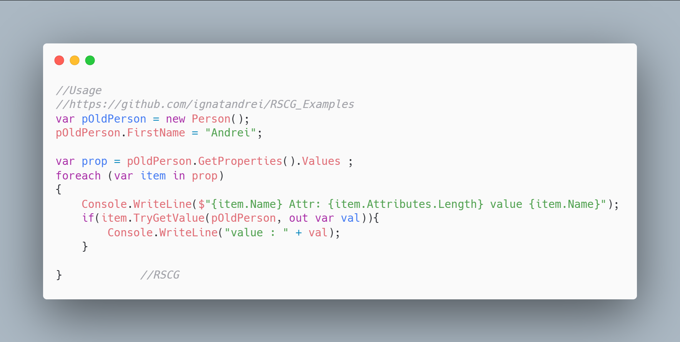 [code](http://ignatandrei.github.io/RSCG_Examples/images/ApparatusAOT/Usage.cs)

#### The code that is generated by RSCG ApparatusAOT

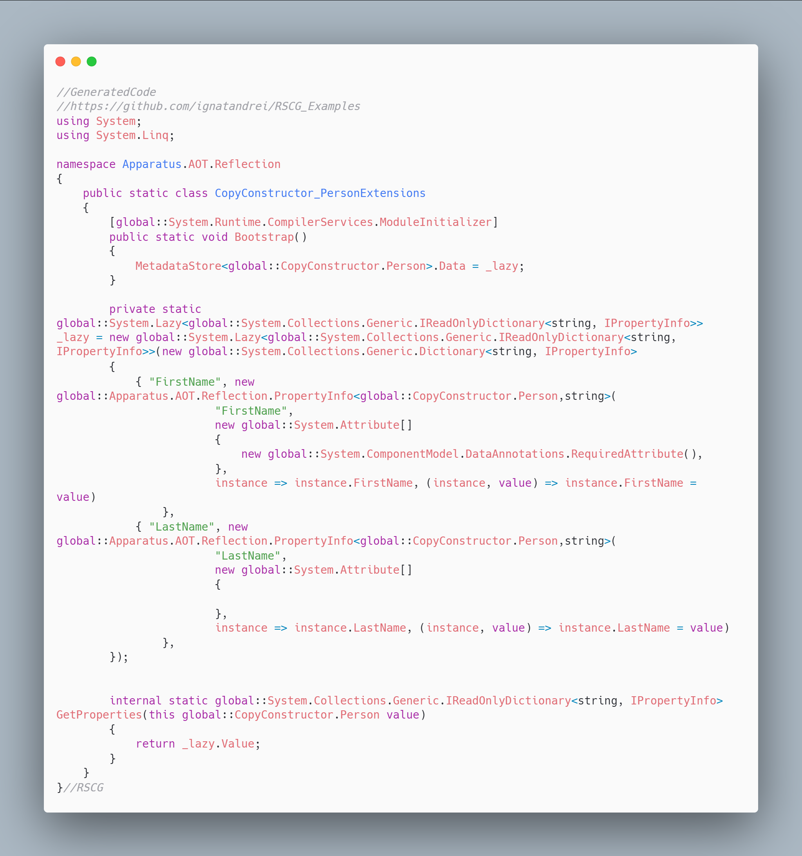 [code](http://ignatandrei.github.io/RSCG_Examples/images/ApparatusAOT/GeneratedCode.cs)

### More details about RSCG ApparatusAOT

The author of **RSCG ApparatusAOT** is *Stanislav Silin*

You cand find **RSCG ApparatusAOT** at Nuget.org : <https://www.nuget.org/packages/Apparatus.AOT.Reflection/> and the sources at <https://github.com/byme8/Apparatus.AOT.Reflection>

For more usage features please read : <https://github.com/byme8/Apparatus.AOT.Reflection>

#### Link to Example Code:

[<https://github.com/ignatandrei/RSCG_Examples/tree/main/ApparatusAOT>](https://github.com/ignatandrei/RSCG_Examples/tree/main/ApparatusAOT)

### Author of ApparatusAOT , Stanislav Silin

#### Short info about you , Stanislav Silin

I am a software developer. Interested in the app architecture and performance optimizations

#### Why did you start this ApparatusAOT ?

I am constantly looking for ways how to reduce the amount of boilerplate code. So, I decided to make a place where I can put all my findings. Maybe they will be useful for someone else. 'Apparatus' is the name of a community/organization. The 'AOT' is just a suffix for the indication that the tool is intended for the AOT scenarios.

#### How do yourself use your ApparatusAOT ?

Right now, ZeroIoc is actively used in one commercial project. Other stuff like AOT.Reflection, DuckInterface in just experiments to investigate the possibility and effectiveness of such tools.

#### What other RSCG do you use ?

At the moment I don't use any of them.

## RSCG number 24 : RSCG_TimeBombComment

### What RSCG RSCG_TimeBombComment can do

This will generate an error from the comment after a certain date

### Example code

#### Here is the csproj with the references for RSCG RSCG_TimeBombComment

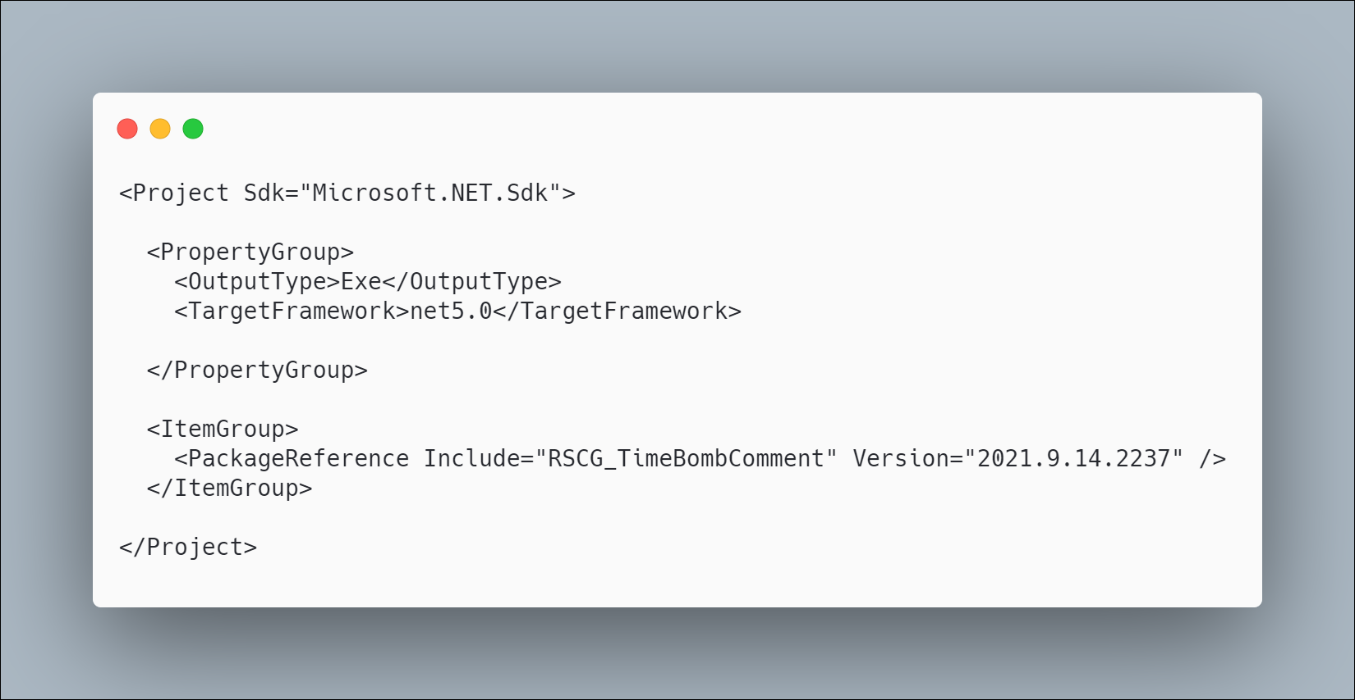 [code](http://ignatandrei.github.io/RSCG_Examples/images/RSCG_TimeBombComment/The.csproj)

#### The initial code that you start with is

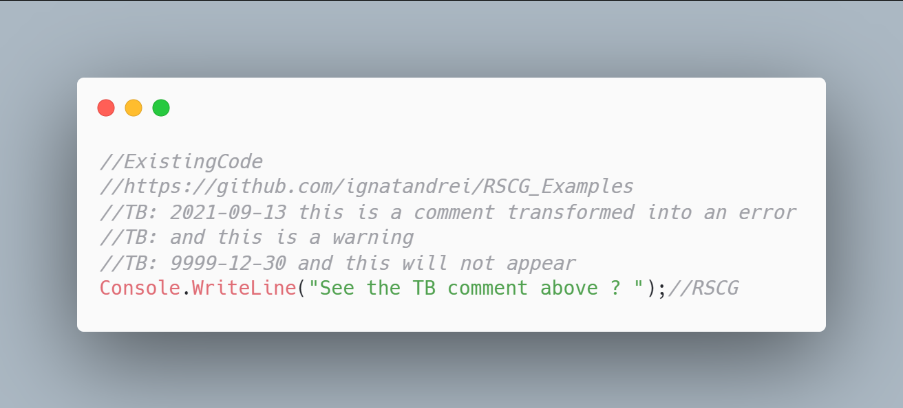 [code](http://ignatandrei.github.io/RSCG_Examples/images/RSCG_TimeBombComment/ExistingCode.cs)

#### The code below will use the RSCG RSCG_TimeBombComment

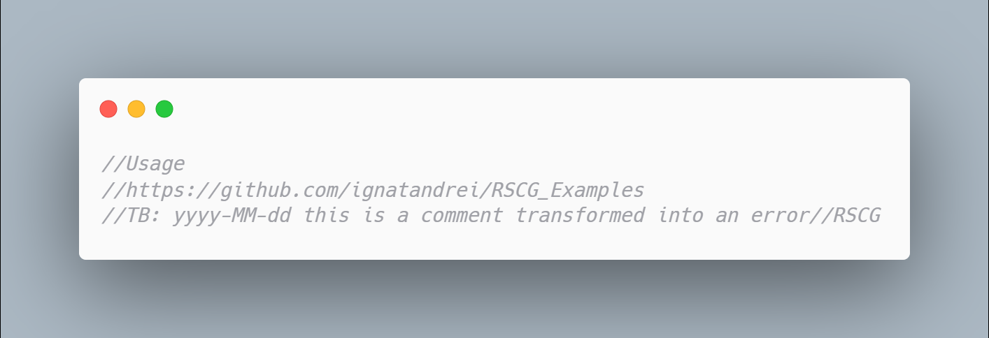 [code](http://ignatandrei.github.io/RSCG_Examples/images/RSCG_TimeBombComment/Usage.cs)

#### The code that is generated by RSCG RSCG_TimeBombComment

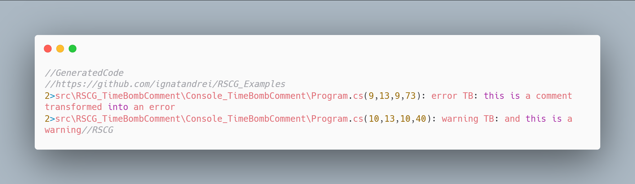 [code](http://ignatandrei.github.io/RSCG_Examples/images/RSCG_TimeBombComment/GeneratedCode.cs)

### More details about RSCG RSCG_TimeBombComment

The author of **RSCG RSCG_TimeBombComment** is *Andrei Ignat*

You cand find **RSCG RSCG_TimeBombComment** at Nuget.org : <https://www.nuget.org/packages/RSCG_TimeBombComment/> and the sources at <https://github.com/ignatandrei/RSCG_TimeBombComment>

For more usage features please read : <http://msprogrammer.serviciipeweb.ro/category/roslyn/>

#### Link to Example Code:

[<https://github.com/ignatandrei/RSCG_Examples/tree/main/TimeBombComment>](https://github.com/ignatandrei/RSCG_Examples/tree/main/TimeBombComment)

## RSCG number 26 : BoilerplateFree

### What RSCG BoilerplateFree can do

This will generate interface from a class

### Example code

#### Here is the csproj with the references for RSCG BoilerplateFree

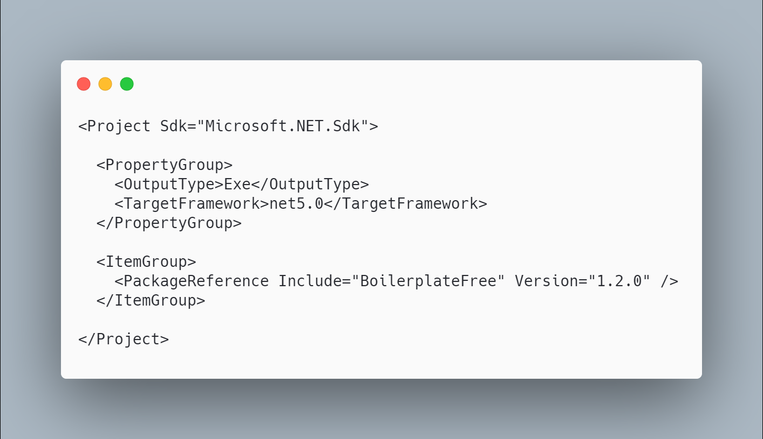 [code](http://ignatandrei.github.io/RSCG_Examples/images/BoilerplateFree/The.csproj)

#### The initial code that you start with is

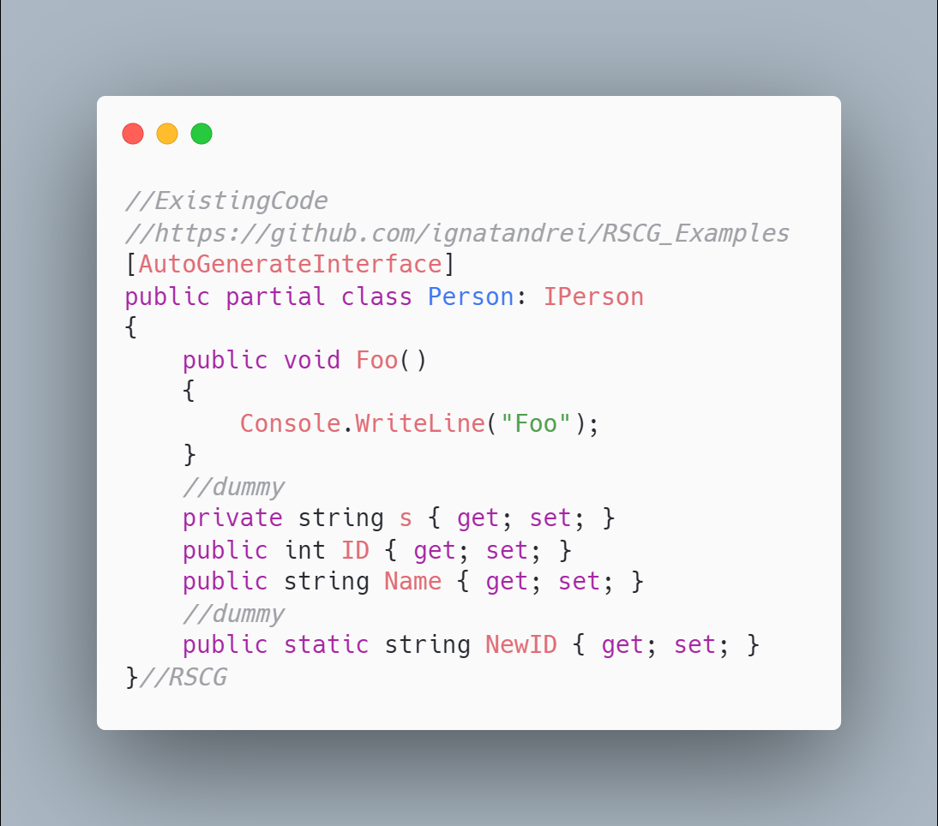 [code](http://ignatandrei.github.io/RSCG_Examples/images/BoilerplateFree/ExistingCode.cs)

#### The code below will use the RSCG BoilerplateFree

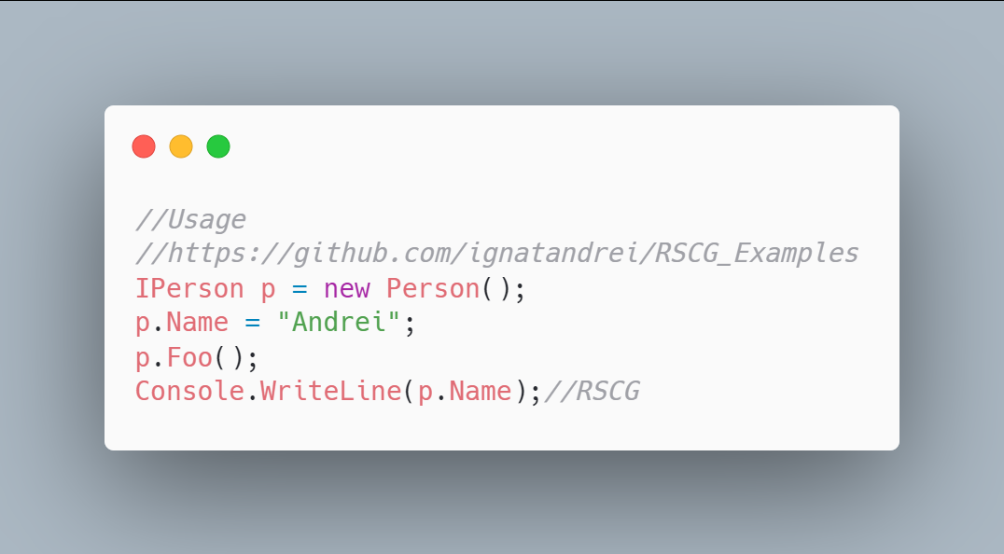 [code](http://ignatandrei.github.io/RSCG_Examples/images/BoilerplateFree/Usage.cs)

#### The code that is generated by RSCG BoilerplateFree

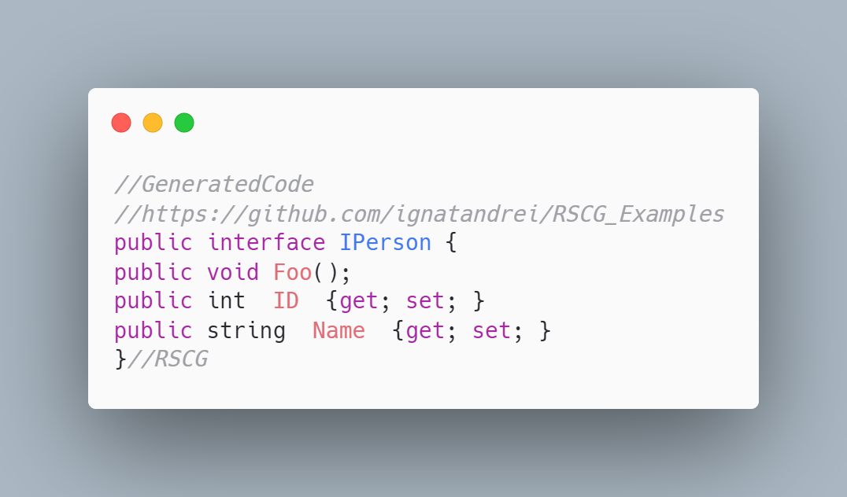 [code](http://ignatandrei.github.io/RSCG_Examples/images/BoilerplateFree/GeneratedCode.cs)

### More details about RSCG BoilerplateFree

The author of **RSCG BoilerplateFree** is *Gustav Wengel*

You cand find **RSCG BoilerplateFree** at Nuget.org : <https://www.nuget.org/packages/boilerplatefree> and the sources at <https://github.com/GeeWee/boilerplatefree>

For more usage features please read : <https://github.com/GeeWee/boilerplatefree>

#### Link to Example Code:

[<https://github.com/ignatandrei/RSCG_Examples/tree/main/Class2Interface>](https://github.com/ignatandrei/RSCG_Examples/tree/main/Class2Interface)

### Author of BoilerplateFree , Gustav Wengel

#### Short info about you , Gustav Wengel

I'm a 28 year old software developer from Aarhus, Denmark. I work primarily within CleanTech as I think the climate emergency is one of the most pressing issues we face currently. I've worked with C# and .NET for about two years.

#### Why did you start this BoilerplateFree ?

Because I thought some of the limitations that the C# language offers sucked. I saw things like Project Lombok in the Java space that made the language much more ergonomic, and I wanted to see if I could bring some of that stuff into the C# space.

#### How do yourself use your BoilerplateFree ?

I use it for a few small-scale production projects. I think the jury is still out whether or not using source generators this way is a good idea or not, but so far it's been a real positive experience.

#### What other RSCG do you use ?

None yet.

#### Any other feedback ?

Nope!

## Roslyn Source Code Generator (RSCG ) - others

There are more awesome RSCG that you could use - here is a list of 53 RSCG that you may want to look at:

### Conclusion

I am happy that you have read / or practice / the RSCG presented in this book. I hope that inspired you to produce yours - and send me to review and maybe add to this book .

### One hour of free consultancy

If you bought this book from Amazon, <https://amzn.to/3f6gll3>, you are entitled to have 1 hour free of consultancy with me.

Thanks ! Andrei